Chapter in
Oxford Handbook of Musical Identities
Ed. MacDonald, R., Hargreaves, D. and Miell, D.
2015

IDENTITY AND MUSICAL DEVELOPMENT IN PEOPLE WITH SEVERE OR PROFOUND AND MULTIPLE LEARNING DIFFICULTIES

Adam Ockelford and John Vorhaus

- INTRODUCTION

What can we learn about someone’s identity from their capacity to engage with music? In this chapter we examine the relationship between identity and musical engagement on the part of children and young people with either severe learning difficulties (SLD) or profound and multiple learning difficulties (PMLD). We consider identity as it relates to a sense of self, we look at the concept of a ‘musical identity’, and we draw some distinctions that are applied to six children engaging in a range of musical activities.

There are many terms in common parlance that purport to refer to the self, and an abundance of theories that seek to account for its existence. Philosophers, psychologists, neuroscientists and cognitive scientists each have an array of rival candidates, and, beyond the most minimal claims, each is the subject of ongoing debate. No one, or almost no one, doubts whether individual people exist. But whether we should also allow that we possess or are even conscious of a self, and how this is related to our identity, remain keenly contested questions. These largely fall into three categories: there is a phenomenological question concerning what exactly we are aware of, or conscious of, or have experience of in relation to a self; there is an epistemological question of how we arrive at any knowledge of or about the self, whether that self is ours or somebody else’s; and there is a metaphysical question about what there is, in the way of a self, and how the self is related to our experience.

These questions are always difficult, but some aspects are especially problematic in the context of those with SLD and PMLD. This is because such people are unable to speak about these subjects for themselves. That is one reason for exploring their engagement with music, which may enable them both to communicate and to develop a musical identity in the absence of verbal language.

In a previous paper, Ockelford and Welch (2012) made reference to Gallagher’s (2000) suggestion that philosophical conceptions of the self can be divided into two groups, according to whether they tend towards either a ‘minimal’ or a ‘narrative’ self. We will return to this distinction and draw attention to a number of questions that arise in relation to conceptions of the self, and how these are manifested in musical engagement. In section 2 we introduce the Sounds of Intent project, and in section 3 we show how the music-developmental framework that it sets out is related to various stages in the evolution of the sense of self, illustrating our argument with evidence from six case studies.

- THE SOUNDS OF INTENT PROJECT

The Sounds of Intent project was set up in 2002 as a joint venture by the University of Roehampton and the Institute of Education, London. The aim was to map the musical development of children and young people with learning difficulties, an aspiration that has now been achieved following research over a number of years (see, for example, Ockelford, Welch, Zimmermann and Himonides, 2005; Welch, Ockelford, Carter, Zimmermann and Himonides, 2009; Cheng, Ockelford and Welch, 2010; Ockelford and Matawa, 2010; Ockelford, Welch, Jewell-Gore, Cheng, Vogaitzoglou and Himonides, 2011). In the absence of pre-existing data or theories, the Sounds of Intent team adopted an empirical approach to exploring what musical development in young people with SLD or PMLD might mean. Working with a group of practitioners who were active in the field, principally music teachers and therapists, the research team developed shared interpretations of the different forms and levels of musical engagement that they observed among their pupils and clients. The children’s responses, actions and interactions were encapsulated in short descriptions such as those shown in Table 1.

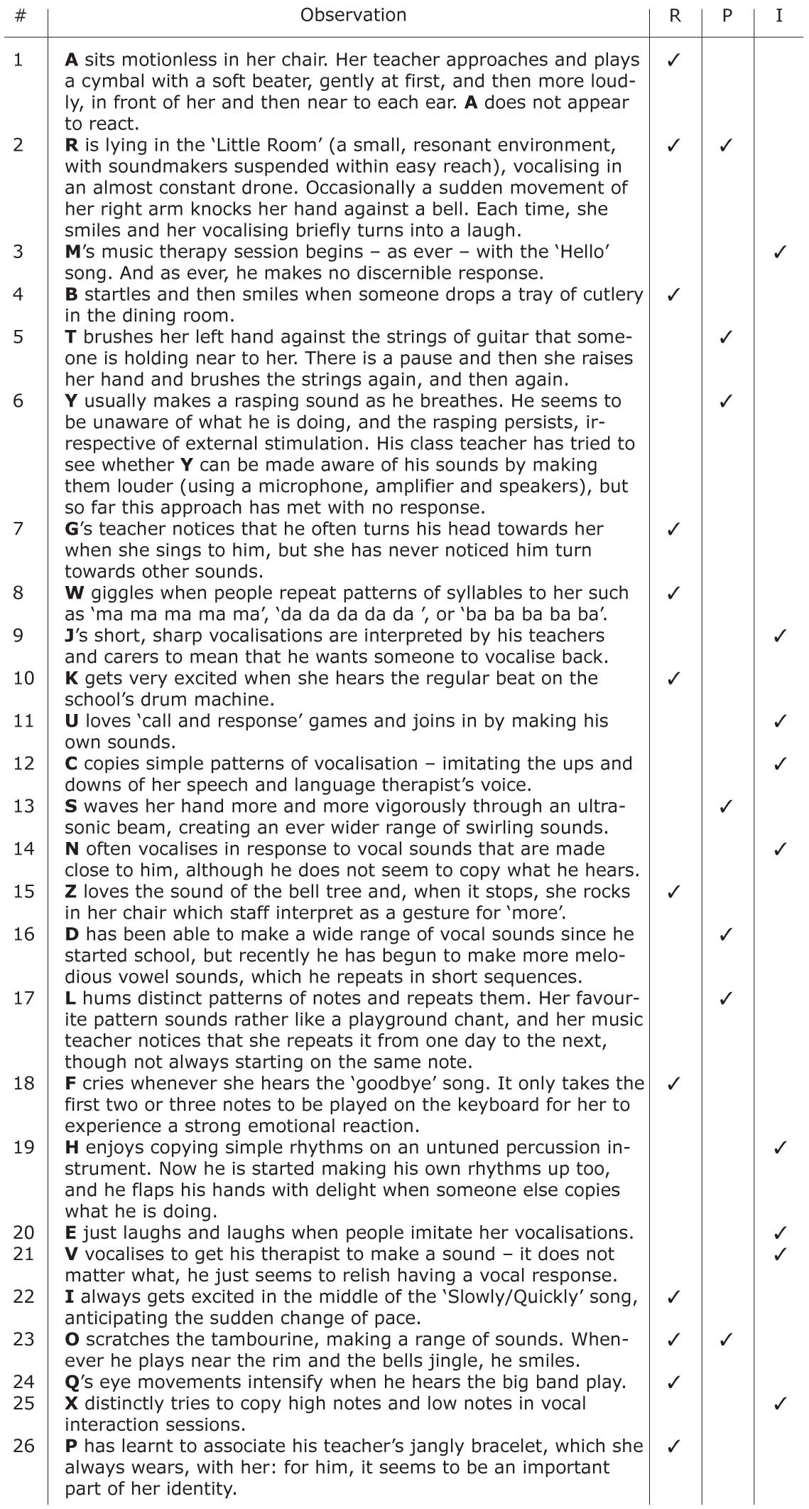

Table 1 Observations of musical engagement by children and young people with PMLD (after Ockelford, Welch, Jewell-Gore, Cheng, Vogiatzoglou and Himonides, 2011).

Examples such as these showed that musical development could not be conceptualised in terms of a single dimension, since (for example) an individual’s capacity for attending to sounds may well be greater than her or his ability to produce them. Therefore, at least two dimensions were required, and these were conceived as ‘listening and responding’, for which the term ‘reactive’ (‘R’) was used, and ‘causing, creating and controlling’, for which the label ‘proactive’ (‘P’) was adopted. In Table 1, observations 1, 2, 4, 7, 8, 10, 15, 18, 22, 23, 24 and 26 were considered to be entirely or predominantly ‘reactive’ and 2, 5, 6, 13, 16, 17 and 23, ‘proactive’. This left other observations (as in examples 3, 9, 11, 12, 14, 19, 20, 21 and 25), in which listening to sounds or making them occurred in the context of musical participation with others. It seemed that this form of activity merited the status of a distinct dimension, which was termed ‘interactive’ (‘I’). While the three dimensions are not entirely discrete, the crucial thing was that the conceptualisation was deemed by practitioners to be meaningful in terms of categorising the types of musical engagement that they observed.

A number of attempts were made to place examples such as those shown in Table 1 along each of the three dimensions that had been identified: (a) reactive (in response to another), (b) proactive (initiating behaviour without an obvious external prompt), and (c) interactive (with another). The location of the examples within a dimension was based on contingency, where each was identified as a necessary precursor or possible successor to another. For instance, it was clear that an awareness of sound (Example 2) must precede a differentiated response (Example 7), which in turn must precede the capacity to anticipate change (Example 22). This heuristic approach was necessary since the available evidence largely comprised observations of different children at various stages of development, rather than longitudinal data on the same children as they matured. Taking this exploratory tack was, however, deemed valid as a preliminary step, since it was believed that longitudinal studies of children with PMLD would be likely to last for several years at least. It was felt, though, that once an initial model had been developed, this could be used to inform longer-term empirical work.

Different configurations of the Sounds of Intent model were proposed and systematically trialled in the field. Practitioners offered feedback, which allowed the research team to refine the model, enabling it to capture a wider range of musical behaviours, and enhancing intra- and inter-domain consistency (Welch, Ockelford, Carter, Zimmermann and Himonides, 2009). Eventually, six levels of music-processing capacity emerged; see Table 2.

Level | Description | Core cognitive abilities
1 | Confusion and Chaos | None: no awareness of sound as a distinct perceptual entity
2 | Awareness and Intentionality | An emerging awareness of sound as a distinct perceptual entity  and of the variety that is possible within the domain of sound
3 | Relationships, Repetition, Regularity | A growing awareness of the possibility and significance of  relationships between the basic aspects of sounds
4 | Sounds Forming Clusters | An evolving perception of groups of sounds, and the relationships  that may exist between them
5 | Deeper Structural Links | A growing recognition of whole pieces, and of the frameworks  of pitch and perceived time that lie behind them
6 | Mature Artistic Expression | A developing awareness of the culturally determined  ‘emotional syntax’ of performance that articulates  the ‘narrative metaphor’ of pieces

Table 2 The six levels of the Sounds of Intent framework (acronym ‘CIRCLE’).

Placing these six levels across the three domains of musical engagement that had been identified gave rise to 18 ‘level descriptors’ of reactivity, proactivity and interactivity. Visually, these were arranged as segments in circular form, which the practitioners on the Sounds of Intent team regarded as being an appropriate metaphor for children’s development, ranging from the centre, with its focus on self, outwards, to increasingly wider communities of others.

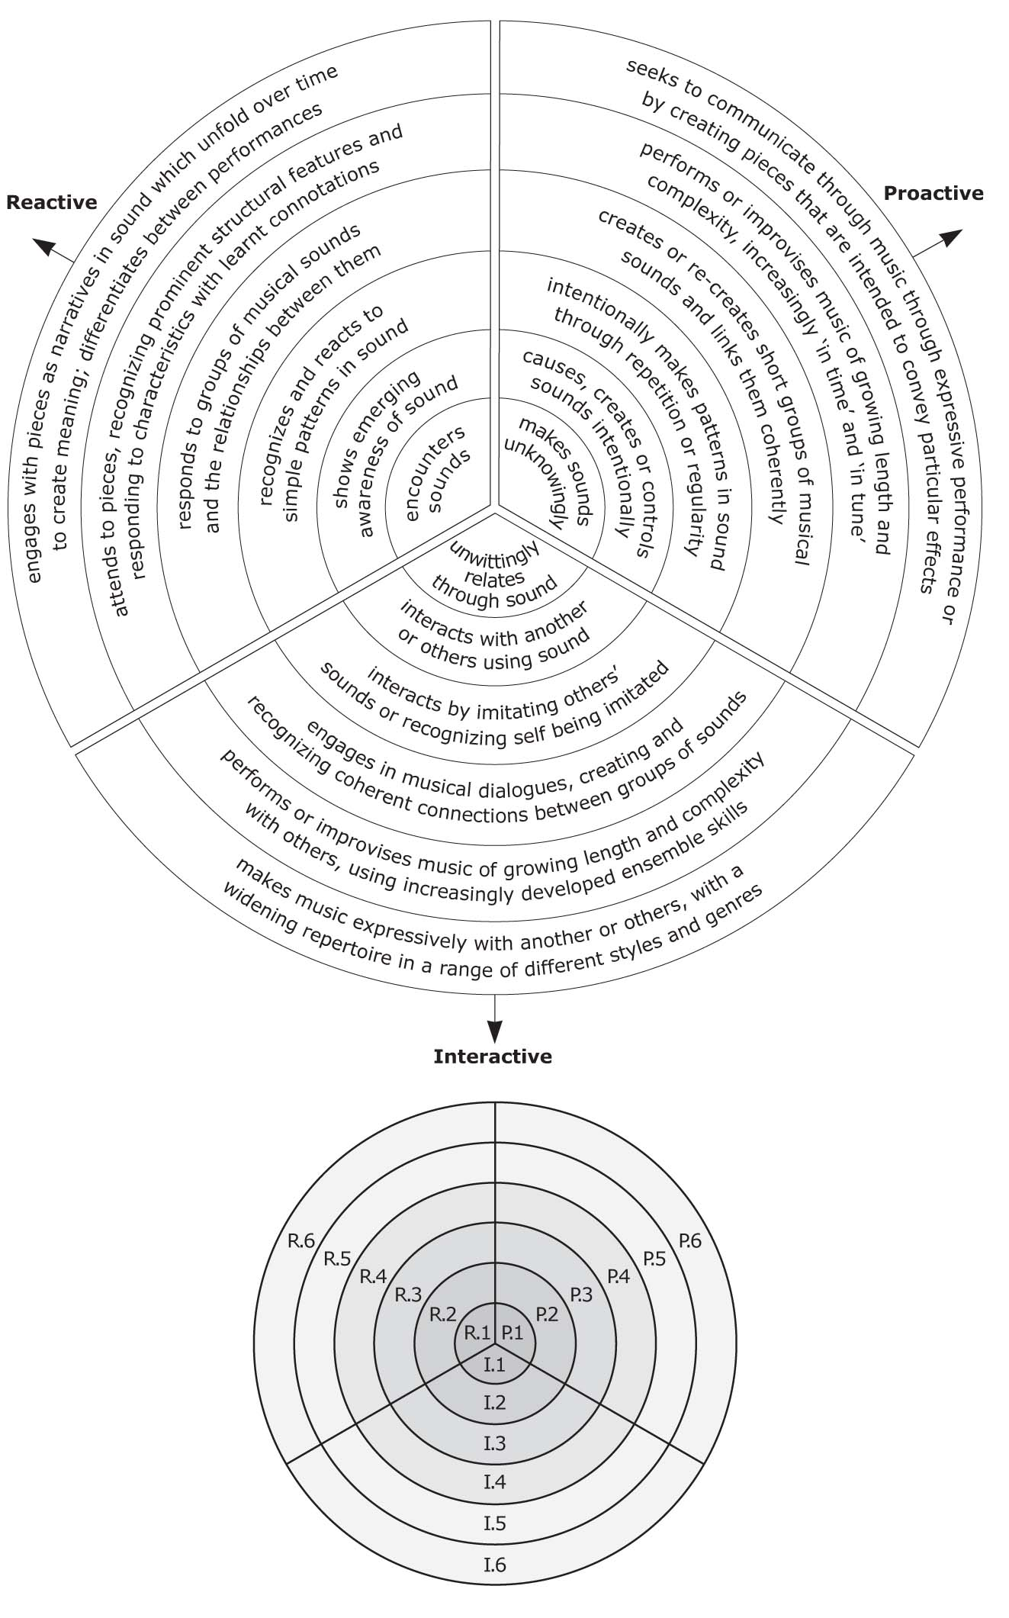

Figure 1 The Sounds of Intent framework.

For ease of reference, levels were ranked from 1–6, each of which could be preceded with an ‘R’, a ‘P’ or an ‘I’, to indicate, respectively, reactive, proactive or interactive segments. Each was broken down into four more detailed ‘elements’, as the examples in Table 3 show.

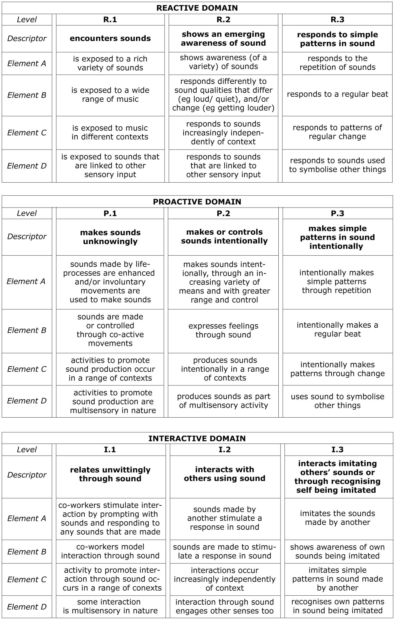

Table 3 Elements at Levels 1–3 in the reactive, proactive and interactive domains.

- RELATING THE SOUNDS OF INTENT FRAMEWORK TO A SENSE OF SELF

The Sounds of Intent framework

Although the Sounds of Intent project focussed on children’s evolving capacities to engage with music, these cannot be separated from wider cognitive, emotional and social development; indeed, there is a substantial body of research indicating that music is typically a key element in one’s maturing sense of intrapersonal and interpersonal identity (MacDonald, Hargreaves and Miell, 2002). Hence it should be possible to relate conceptions of the self to the six Sounds of Intent levels of musical development. We will approach the issue first by setting out a theoretical connection between the Sounds of Intent framework and an evolving sense of self, before introducing Gallagher’s notions of ‘minimal’ and ‘narrative’ selves, a number of philosophical questions that this distinction raises, and a series of case studies designed to illustrate the model that is proposed.

First, we consider how the Sounds of Intent levels relate more widely to early communication, since this will offer a broader context for what is proposed. Ockelford (2002) sets out a four-phase model of the development of expressive communication, which is reproduced in simplified form here, with the addition of a fifth stage, pertaining to pragmatics (see Table 4).

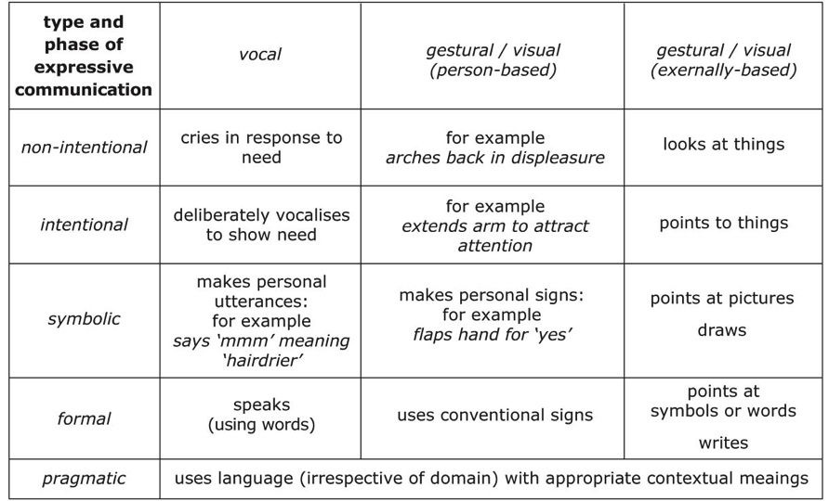

Table 4 Model of the development of early communication (after Ockelford, 2002).

These five phases can be mapped onto the six Sounds of Intent levels as shown in Table 5 (cf. Ockelford, 2008, p. 132).
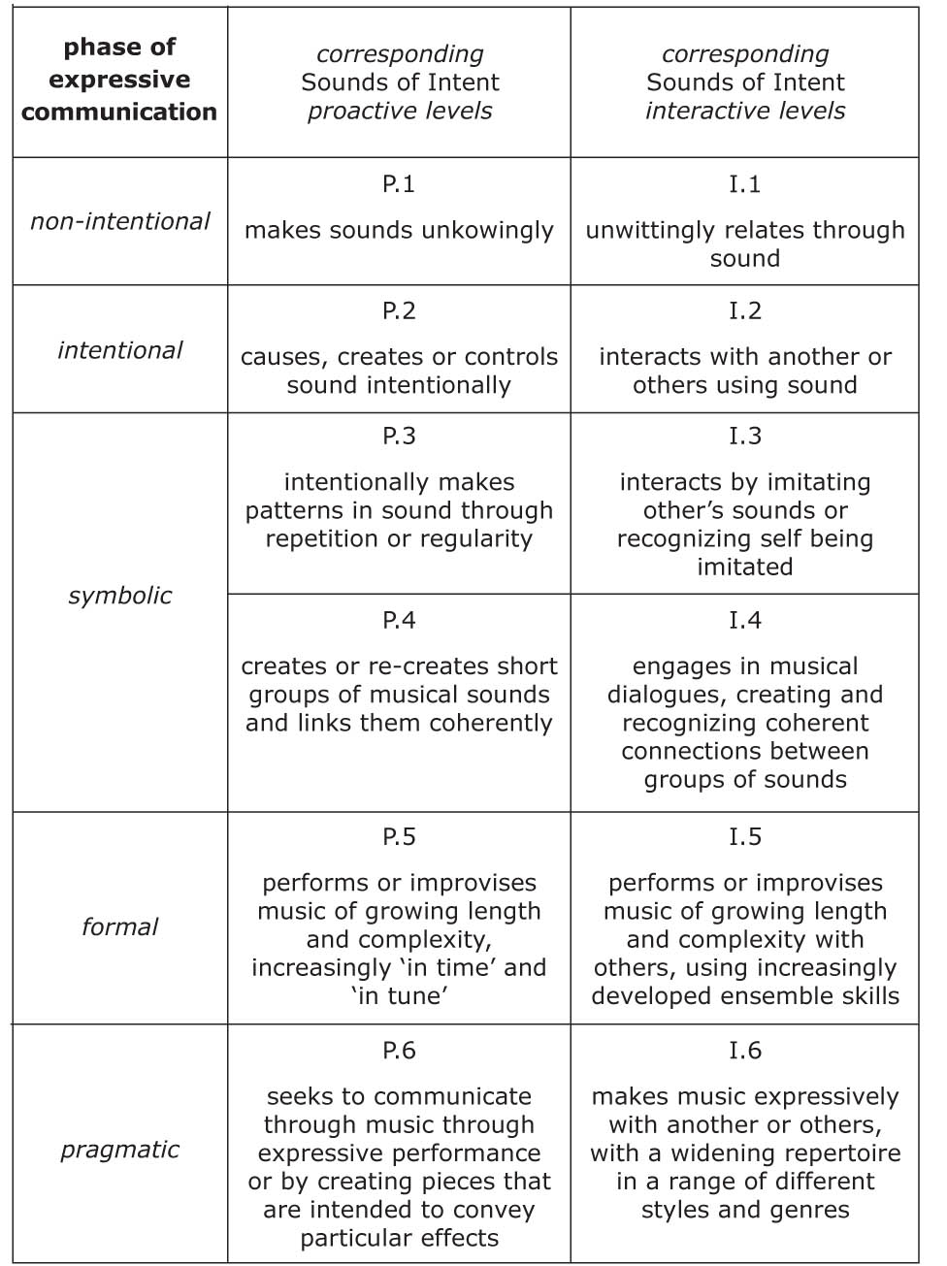
Table 5 Sounds of Intent levels mapped onto the model of early expressive communication.

To consider how this composite developmental map may relate to an evolving self we can refer to Gallagher’s distinction between the minimal self, considered as ‘a consciousness of oneself as an immediate subject of experience, unextended in time,’ and the narrative self, considered as ‘self-image that is constituted with a past and a future in the various stories that we and others tell about ourselves’ (2000, p. 150). We can initially elaborate on this distinction as follows (see Table 6).

Domain | minimal self | narrative self
perceptual / cognitive processing | pure sensation (perceptual)  phenomenally conscious | interpretation of sensations (cognitive)  consciousness of self
temporal status | Awareness of perceived present | Awareness of past, present and future
symbolic representation | no | yes – can take the form of language

Table 6 Initial elaboration of Gallagher’s ‘minimal’ and ‘narrative’ sense of self.

Table 6 offers an interpretation of Gallagher’s ‘minimal’ and ‘narrative’ selves in terms of perception and cognition, perceived temporal status and symbolic representation. By drawing together the elements of Table 5 and Table 6 we might surmise that musical development and growing self awareness can evolve together along the following lines (see Table 7):

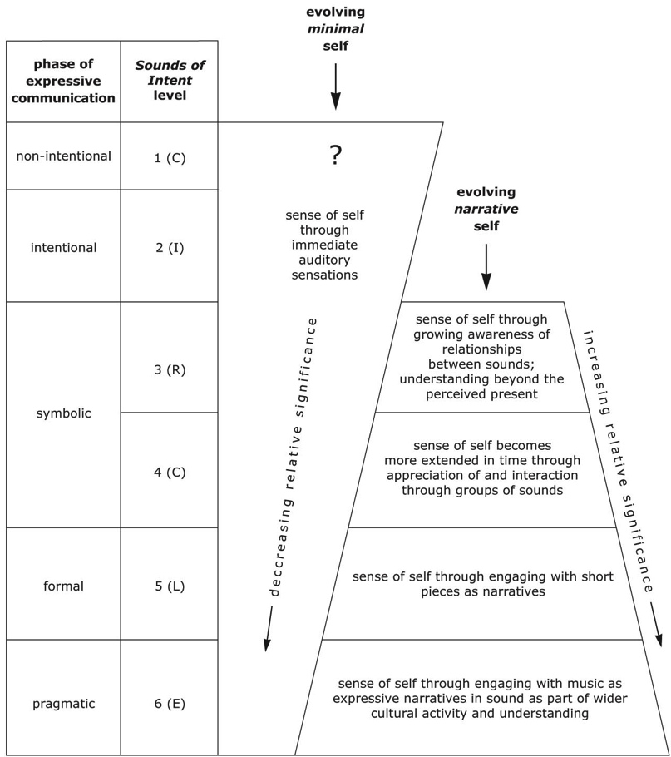

Table 7 Parallels between stages of musical development and an evolving sense of self (cf. Tables 2 and 5).

We can now elaborate on conceptions of the minimal and narrative self, whilst also exploring how the frameworks introduced in this section can be used to illustrate the relationship between musical engagement and self development. In the sections that follow we introduce six case studies each considered in relation to one of the six levels that together comprise the Sounds of Intent framework.

The ‘minimal’ self: consciousness and self-consciousness

Gallagher (2000) conceives the minimal self phenomenologically:

that is, in terms of how one experiences it, a consciousness of oneself as an immediate subject of experience, unextended in time … Even if all of the unessential features of self are stripped away, we still have an intuition that there is a basic, immediate, or primitive ‘something’ that we are willing to call a self (Gallagher, 2000: 15).

The minimal self is characterised here in terms of phenomenal consciousness – consciousness of oneself as an immediate subject of experience. Bayne distinguishes between phenomenal states and phenomenally conscious creatures:

A phenomenal state is a state that there is something it is like to be in. Phenomenal states are individuated in terms of their phenomenal character – that is, in terms of what it is like to be in them. There is something it is like to hear a siren sound … to see a field of daffodils in spring … to smell freshly brewed coffee … A phenomenally conscious creature is a creature that there is something it is like to be. Phenomenally conscious creatures, and only phenomenally conscious creatures, have a phenomenal perspective (Bayne 2007: 1).

Creature consciousness is not identical with wakefulness: dreamers can be phenomenally conscious without being awake, and it is conceivable that patients in a vegetative state could be awake without being phenomenally conscious (Bayne, 2007: 21). All the subjects of our case studies are in a state of wakefulness; our principal interest is the distinction between phenomenal states and phenomenally conscious creatures, between there being something it is like to hear a musical sound and something it is like to be a phenomenally conscious creature – someone who has a phenomenal perspective on their musical experience.

The Sounds of Intent Framework: Level 1

There is something it is like to be each one of the 6 children we discuss below, and most of the children will have a phenomenal perspective on their musical experience, certainly those at and above level 2. But what about those at level 1? Level 1 includes ‘non-intentional’ communication – ‘crying in response to a need’, ‘making sounds unwittingly’ and ‘unwittingly relating through sounds’. Although these criteria include multiple possibilities, children functioning at this level may not experience their actions as making or responding to sound; they may not even be aware of the sounds that they are producing. It would be unwise categorically to assert that they are unaware of sound, or of the sound that follows their cries. It is even possible that they should have some awareness that the sound they unwittingly produced is in some way related to something that they have done. But even were they to have some such awareness, this is at a considerable distance from being aware that they are responsible for the sounds that they can hear. Any such person is unlikely to have a sense of self, nor a sense of self characterised by engagement in music, nor, therefore, anything that we would recognise as a musical identity. Our first case study provides an illustration of some of these points.

Case study 1: Joe

Joe suffered perinatal brain injury, which profoundly affected his development. Today, aged six, his Sounds of Intent assessment is as follows:

REACTIVE – LEVEL 1
Observation
Joe appears to pay no attention to the wide range of sounds to which he is exposed, and no responses can be observed.
Interpretation
His teacher takes this to mean that Joe does not process sound as a distinct or meaningful sensory experience.

PROACTIVE – LEVEL 1
Observation
The only sounds Joe makes occur as a consequence of certain life-processes such as breathing, for example.
Interpretation
Joe’s teacher believes that he is unable to act with volition on his environment; he appears to have no sense of agency.

INTERACTIVE – LEVEL 1
Observation
Attempts to interact with Joe through sound (for example, by physically supporting him to produce sounds in response to those that are created in his environment, or by responding to the sounds he makes through inhaling and exhaling) have no apparent effect.
Interpretation
This is interpreted as Joe having no sense of interagency involving himself and another person in the domain of sound.

This assessment suggests that Joe does not have even a minimal sense of self as defined by Gallagher, since he appears neither to have the capacity to process incoming sensory input (implying that he has no sensation of sound as it is generally understood) nor to be capable of acting with volition on his environment. It would also appear that he lacks any consciousness of a ‘self’, or of himself as someone interacting with others, or of one and the same self enduring over time. It could be that there exists a more primitive sense of self than the ‘minimal’ self or it may be that the concept of the ‘minimal’ self needs to be extended, since recent neuro-scientific research has shown that patients who are unable to make voluntary ‘bedside’ responses may nonetheless be able to communicate through the wilful modulation of brain activity (Monti, Vanhaudenhuyse, Coleman, Boly, Pickard, Tshibanda, Owen and Laureys, 2010). Since Joe’s brain trauma occurred at birth, it seems unlikely that he would have acquired the necessary bank of sensory experiences required for the operation of the mechanism that is the subject of the protocol used by Monti et al. Nevertheless, it would be unwise categorically to assert that Joe has no sense of self unless and until this was the subject of a conclusive demonstration, although it is not immediately obvious what form any such demonstration would take.

The Sounds of Intent Framework: Level 2

Being a phenomenally conscious creature is related to having self-conscious experience, or, as Strawson puts it, experiencing oneself specifically as oneself’ (Strawson: xxi). Strawson proposes that we have experience of ourselves as a ‘thing’ of some sort, and he characterises this negatively by suggesting that:

the alternative to experiencing oneself as a thing of one sort, in self-experience, would be to experience oneself as ‘merely’ a property of something, in some manner, or as ‘merely’ a process experienced as something that essentially involves the existence of an object or substance that is distinct from it and in which it can go on and occur (Strawson: ibid.).

It may seem odd to refer to the self as a ‘thing’, and some reject this notion; yet insofar as the self features in our experience, it is not as a state or a property or an event, or even as some sort of process. As Nozick writes, the self ‘has a particular character, that of an entity’ (Nozick 1989: 148). Perhaps the most important sense in which the self presents itself as a thing of some sort is related to how it presents itself as a subject of experience. We might think that each of us has a good basic understanding of what a subject of experience is just by virtue of being one and being self conscious (Strawson 2011: 63). That understanding does not require that we should be able to articulate what it is like, or what we understand by the notion. Strawson argues that the basic understanding is:

available to young children, and it lies at the centre of ordinary human self-experience, and indeed of any self-experience at all, whether or nor we can give it clear verbal expression. It’s plausible that no sane self-conscious subject of experience can fail to have a good grasp of what a subject of experience is. (Strawson 2011: 64).

Someone operating at Level 2 of the Sounds of Intent framework is capable of intentional expressive communication – for example ‘causing, creating or controlling sounds intentionally’ and ‘interacting with others by using sounds’. Is someone with these capabilities necessarily self conscious or in possession of a good grasp of what a subject of experience is? It would appear not. It is plausible that some birds are capable of causing a sound intentionally and interacting with others using sounds, yet it is not plausible that these birds are conscious of themselves, nor that they understand that they are subjects of experience. The intentionality required by Level 2 is exhibited by animals that lack self consciousness. But equally some birds (and other animals) can produce sounds that can be interpreted as music to human ears (Ockelford 2013a: 141–143) and – conceivably – to theirs. Moreover, it would be dogmatic to assert that we cannot attribute the requisite intentionality to artificial intelligence, although whether we can also attribute self consciousness to any such intelligence is a moot point.

Intentionality as exhibited in the communication of sounds is not sufficient for self consciousness, not even if the sounds intentionally communicated are judged by us to be musical (Ockelford 2013b: 45–52). It follows that self consciousness is not a necessary condition for the earliest stages of musical development; nor are the earliest stages of musical development sufficient for self consciousness.

Self conscious experience requires that one is aware of oneself as a subject of experience – one is both aware of sound, for example, and conscious that one is aware of sound. A bird may be aware of sound yet not conscious of being aware of this, whilst any human being with at least a minimal sense of self will have the requisite awareness. This is not yet to posit a musical identity, which implies some awareness of being musical; but it is to suggest how self-awareness is related to the presence of a minimal self, and our having a sense of that.

Our second case study – of Emily – illustrates someone who is developing a minimal sense of self.

Case study 2: Emily

Emily has cerebral palsy and PMLD. She is 12 years old. Her Sounds of Intent assessment is as follows.

REACTIVE – LEVEL 2
Observation
Emily responds to loud sounds (such as the clash of symbols or the bang of a drum near to her) with a smile, though quieter sounds appear to elicit no response.
Interpretation
Emily’s music therapist takes this to mean that Emily can process certain stimuli in the auditory domain.

PROACTIVE – LEVEL 2
Observation
In the ‘little room’ (a specially constructed micro-environment in which she lies supine), Emily will reach up to the cowbell that is suspended from above and strike it with her hand to make it sound.
Interpretation
Emily’s teacher interprets this is evidence of her having a sense of agency, with the necessary cognitive and motor capacities to produce or control sounds intentionally.

INTERACTIVE – LEVEL 2
Observation
In the multisensory room, Emily will operate a switch to turn on lights and music, but only when prompted by her support worker sitting very close to her and singing ‘turn on the switch’ in her ear.
Interpretation
Emily’s educational psychologist believes this shows that she has some notion of a sense of interagency that can exist between her and another person.

This assessment suggests that Emily has a minimal sense of self – pre-linguistic and non-conceptual – a sense that is reinforced through repeated perceptual experience. In the absence of verbal confirmation, the strongest evidence for this stems from her interactions in the multisensory room, where the singing of Emily’s support worker is required to prompt her to turn the music on, which is arguably indicative of an early sense of self and other. There is, therefore, evidence that Emily is developing some (minimal) capacity to relate to another person, and this in turn is likely to have a developmental impact on the sense that she has of herself.

The narrative self: time, memory and the narrative of others

Gallagher contrasts the minimal self with a narrative self. The narrative self is conceived as:

a more or less coherent self (or self-image) that is constituted with a past and a future in the various stories that we and others tell about ourselves … The narrative self is extended in time to include memories of the past and intentions toward the future’ (Gallagher 2000: 15).

The narrative self requires a sense of past and future, and this presupposes a sense of time. Clarke elucidates how music is related to temporality, experience and consciousness:

[M]usic models, moulds, and makes audible the flow of our inner, subjective life – the sense of our being-in-the-world … these processes and their musical analogues are by definition temporalities. To be conscious is to know one’s being from one moment to the next and to generate some apprehension of unity – an enduring self, an enduring world (whether ‘real’ or illusory) – out of the experience. And while much in the everyday business of human doing furnishes such conditions for consciousness, the making of music might be argued as distinctive in these respects, since ‘musicking’ captures in its very temporal essence the temporality that is essential to the knowing of being – i.e. consciousness (Clarke, 2011: p. 1.)

The Sounds of Intent Framework: Level 3

It is a significant question how musical engagement offers evidence that a child has a sense not only of an ‘inner, subjective life’ but also of an ‘enduring self’ – of being the same subject of experience over time. To explore how engagement in music might provide evidence of a sense of a single, enduring self we would have to explore temporality in such cases as when someone is exposed to a single tone, in its various phases, or to a melody, when this is apprehended as more than an unsynthesised succession of notes (Clarke, 2011: 2). Within the Sounds of Intent framework we would most naturally be exploring people who are at level 3, who show a ‘growing awareness of the possibility and significance of relationships between the basic aspects of sounds’. And we would explore not only how any such awareness was evidence of a sense of a narrative self, but also how it might contribute to an emerging sense of musical identity, an identity characterised by some emerging responsiveness to sound experienced as music.

Consciousness of time and self is manifest not only in how people listen to music but also in how they perform. Montague writes:

A performer who uses his or her body to produce sound through the medium of an instrument will need to know through physical gesture exactly ‘what comes next’ and ‘what has just been’; and this knowledge, contained in the body, will rely on the experience of the melody as a serial temporal succession’ (Montague 2011: 36).

Montague remarks that ‘it is of decisive importance that I play in time’, and that when ‘I am playing, my body is playing now, in a focussed, committed engagement with time. One gesture follows another in necessary succession, and only when I finish, or stop suddenly, will this temporality end’ (Montague 2011: 36).

Whilst practising jazz, Sudnow recalls ‘playing one day and finding … that I’d expressly aimed for the sounds of these next particular notes, that the sounds seemed to creep up into my fingers’ (quoted in Montague 2011: 36). Montague comments on how ‘Sudnow speaks of bodily knowledge, implying that his fingers are themselves agents. Such agency creates a particularly concentrated relationship with time as a series of events’. Children learn to perform music in time, and to recognise that the music they are listening to is being played in time, and this is related to their being conscious of themselves as the same selves existing in time (cf. Husserl: 1905–1910/1964). Someone who can perform music in time and recognise that it is being played in time would probably be operating at (at least) Levels 3 or 4 in the Sounds of Intent framework, showing awareness of the significance of relationships between sounds, and an evolving perception of groups of sounds and of the relationships between them. The emerging sense of a narrative self is therefore related to a growing understanding of how sounds are related to each other, whether at one moment in time, as when listening to a harmony, and over an extended period, as when following a melody or recognising a rhythm or tempo.

Consciousness of time is related to memory. We can distinguish between episodic memory, semantic memory and procedural memory. An example of episodic memory is remembering that my last piano lesson went well; remembering how to play the piano is an example of procedural memory; and remembering that my piano teacher is aged 52 is an example of semantic memory (Tulving 1983). Gallagher emphases the relationship between the narrative self, time and episodic memory (Gallagher 2000: 20):

The importance of the proper functioning of episodic memory and time sense on the formation of the narrative self is indicated by the case of a young boy diagnosed with congenital damage to the right hemisphere and frontal cortex. He suffers from a profound episodic amnesia and because he lacks the ability to quantify the passage of time or to appreciate the meaning of temporal units, he is unable to formulate certain essential structures of narrative, namely, sequential structure and the demarcations of beginning and end (Gallagher 2000: 20)

Engagement with music gives evidence of episodic memory, and this is related to the presence and development of a narrative self, as illustrated in our third case study.

Case study 3: Matthew

Matthew, eight, is blind and has severe learning difficulties. He communicates some everyday needs (such as ‘drink’ and ‘more’) using idiosyncratic sounds and gestures. He appears to understand a few key words when reinforced with on-body signing (for example, ‘toilet’ and ‘swimming’), though his responses to these are not consistent, and it is often hard for his support workers to know whether he has taken the message on board. His Sounds of Intent assessment is as follows.

REACTIVE – LEVEL 3
Observation
Matthew gets very excited when he hears the drum being played – and is particularly responsive to a regular beat that starts quietly and get louder.
Interpretation
Matthew’s music teacher at school takes this to mean that he can recognise simple musical structures that involve regularity and regular change over time.

PROACTIVE – LEVEL 3
Observation
Matthew can maintain to a regular beat on a range of percussion instruments – and he particularly enjoys starting slowly and getting faster.
Interpretation
Matthew’s music teacher interprets this as showing that he can produce simple musical structures that involve regularity and regular change over time.

INTERACTIVE – LEVEL 3
Observation
Matthew enjoys engaging in simple musical dialogues with his music therapist: she taps a drum two or three times and he copies, and vice versa.
Interpretation
Matthew’s music therapist believes that this shows he has a sense of reciprocal imitation: he is happy to be influenced by other people and shows this by copying what they do, and he also likes influencing what others do and understands that this occurs when they copy him.

This assessment suggests that, in addition to a ‘minimal’ sense of self, shown by his responses to immediate auditory experiences, Matthew has an early form of ‘narrative’ self, since he can process sensations over time and appreciate the simple patterns they can make – helping him to remember what has occurred previously and enabling to anticipate what is coming next. Hence he has a (non-conceptual) sense of personal location in time. Although Matthew’s narrative self is pre-linguistic, he is aware at some level that sequences of sound can indicate mutual schemes of influence operating between himself and other people. He therefore gives evidence not only of being aware of his self enduring over time, but of relating to others and understanding that this is what he is doing.

The Sounds of Intent Framework: Level 4

Episodic memory brings us into contact with particular past events and episodes, such as my last piano lesson and the pleasure I took in playing a particular passage well. Sutton writes:

Episodic memories are naturally expressed with a direct object: I remember arguing about Descartes yesterday, and I remember my feelings as we talked. Such personal memories can be generic or specific, and can be memories of more or less extended temporal periods. But the most characteristic feature of episodic remembering, arguably, is the way it brings us into contact with the particular past events which such memories are about and by which they are caused. (Sutton 2012)

This suggests, what Gallagher is elsewhere concerned to emphasise, that episodic memory is related to language, since to remember that I argued with Descartes yesterday, or that I had a piano lesson last week implies that I have the thought, ‘I argued with Descartes yesterday’, or ‘I had a piano lesson last week’, and to have thoughts such as these implies the capacity to use language. Certainly language is integral to Gallagher’s conception of the narrative self:

Humans … have language. And with language we begin to make our experience relatively coherent over extended time periods. We use words to tell stories, and in these stories we create what we call our selves. We extend our biological boundaries to encompass a life of meaningful experience (Gallagher 2000: 19).

Gallagher gives several examples of philosophers and psychologists for whom language is central to the sense of self. For Dennett we cannot help but deploy our capacity to use language in creating our own stories, and Neisser includes a pivotal role for language and narrative play in developing our own self concept (Gallagher 2000: 19). However, a distinguishing feature of the children we are discussing here is a restricted or non-existent capacity to use language. What does a restricted capacity for language imply for the (sense of) development of a self, whether minimal or narrative, and what does engagement with music make possible even when language use and comprehension is (almost) entirely absent? Our fourth case study – Sandip – suggests that it is possible for someone to develop a narrative self even in the absence of a capacity to use and understand language.

Case study 4: Sandip

Sandip, 11, has severe learning disabilities, visual processing difficulties and a diagnosis of autism. Although there is no evidence that he understands language, his reactions suggest that he knows what is going to happen next, and which activities have finished, by using a timetable employing ‘objects of reference’ (Ockelford, 2002). He can make simple choices when presented with two objects of reference at the same time. His Sounds of Intent assessment is as follows.

REACTIVE – LEVEL 4
Observation
Sandip spends a good deal of time listening to excerpts from TV theme tunes. He will listen to the same fragments of music over and over again.
Interpretation
Sandip’s parents (who are musicians) are of the view that their son’s listening preferences indicate that he recognises that music is constructed in distinct ‘chunks’ (though that he is not yet engaging with pieces as extended narratives in sound).

PROACTIVE – LEVEL 4
Observation
Sandip often sings or hums concatenations of musical motifs to himself from different pieces that he has heard.
Interpretation
Sandip’s music teacher interprets this as evidence of his capacity to connect successive groups of notes coherently.

INTERACTIVE – LEVEL 4
Observation
Sandip revels in ‘call and response’ activities in music, vocally copying and sometimes varying short phrases that are sung to him, and taking delight in offering ideas for others to copy, in either case systematically taking turns to listen and contribute.
Interpretation
Sandip’s teacher takes this to mean that he can understand how musical dialogues can be created through imitating groups of sounds to form coherent chains.

This assessment suggests that, as well as a minimal sense of self, Sandip has acquired a significant (though presumably non-linguistic) form of narrative self, since he can understand how series of notes presented over time can form groups, and how these can be used to create more substantial sequences that he can formulate on his own or by participating with others. Through improvised musical exchanges, he can sense the effect of placing his own ideas in a shared domain, and having them picked up, repeated and developed by others; and he is aware of his own capacity to imitate and vary the musical materials that other people offer – all within an extended temporal framework of turn-taking. Hence Sandip is giving evidence of having an awareness of self that includes a developing sense of self-consciousness, a sense of a continuing self enduring over time and a self that is able to interact with and respond to the non-linguistic communicative and other behaviours of his teacher and parents.

The Sounds of Intent Framework: Levels 5 and 6

Ricoeur conceives of the narrative self, not in the manner of Dennett, as an ‘abstract point at the intersection of various narratives’, but as ‘something richer, more substantial and concrete’. In particular, Ricoeur insists that ‘one’s own self narrative is always entangled in the narrative of others’ (Gallagher 2000: 20). This is to make the point that the development of one’s sense of self cannot be considered apart from a social context that includes interpersonal relations, a view frequently adopted in discussion about the concept of a person. Emphasising the relational dimension of personhood Boddington and Podpadek (1991) argue that any definition will embody an element of social construction, and that normative considerations inevitably arise when communities make judgements about whether to accord human beings the status of persons. Boddington and Podpadek also note approvingly that in her discussion of personhood, Midgley (1985) emphasises non-verbal communication, social interaction and the ‘sensibility, social and emotional complexity of the kind which is expressed by the formation of deep, subtle and lasting relationships (Midgley 1985, quoted in Boddington and Podpadek: 187). Kitwood’s view is similar, taking the concept of personhood as ‘a standing or status that is bestowed upon one human being, by others, in the context of relationship and social being’; hence, ‘personhood is not, at first, a property of the individual; rather it is provided, or guaranteed, by the presence of others’ (Kitwood, in Baldwin and Capstick, 2007, p. 246).

The relational aspect of personhood is connected to the relational aspect of the narrative self, for the narrative sense of ourselves is sensitive to how others relate to us as people. Yet people with severe learning difficulties may be regarded by some as not having the status of persons, as if they were less than fully human (Margalit 1998). But if severely disabled people are generally treated as somehow less than people, the likely consequence is withdrawal, inhibition or a sense of rejection. If, on the other hand, they are accepted as people, and recognised as being fully human just like anyone else, this is liable to have a positive or re-enforcing impact on how they think of themselves in the eyes of others, and the confidence they have in themselves as people with whom it is worth interacting.

In our two final case studies we illustrate how a narrative self is revealed by engagement with music on the part of two children with varying linguistic, social and interpersonal abilities.

Case study 5: Mia

Mia has moderate learning difficulties and autism spectrum condition. She is 17 years old. Her verbal communication, though limited to everyday topics, enables her to express her immediate needs, wishes and views effectively. She is proud of her singing abilities, and likes to talk about her musical achievements with her friends and the adults in her life. Mia’s Sounds of Intent assessment is as follows.

REACTIVE – LEVEL 5
Observation
Mia enjoys listening to music on her iPod – particularly pop music. She listens to pieces carefully all the way through and anticipates key structural features such as the choruses of songs.
Interpretation
Mia’s music teacher takes this to mean that she recognises pieces of music as entities comprising sequences of related groups of events that conform to given frameworks of pitch that unfold over time.

PROACTIVE – LEVEL 5
Observation
Mia has taught herself to play the tunes of some of her favourite songs on the keyboard. Her playing is rather ‘wooden’, but the elements appear in the correct order, and she enjoys singing along with her playing.
Interpretation
Mia’s music teacher takes this as confirmation that she has a grasp of pieces of music as structural entities.

INTERACTIVE – LEVEL 5
Observation
Mia provides the lead vocals in her school band. She and her classmates reproduce simple cover versions of well-known pop songs that faithfully follow the structure of the originals, though her capacity to perform with ‘authentic’ expressivity is limited.
Interpretation
Mia’s music teacher regards this group activity as being particularly significant, since it shows that she can attend to others’ performances while performing herself, cognisant of their influence on her, and aware of her own influence on them.

This assessment suggests that Mia’s engagement with music supports her evolving sense of narrative self in two ways, since she can recreate familiar pieces of music with others and is able to reflect on her capacity to perform with those around her. Hence music provides her both with an immanent vehicle for perceiving herself in relation to abstract narratives in sound that unfold over time, as well as a means of relating to others socially, through acknowledged success in musical activity. This recognition is an important element in the construction of her intra- and interpersonal identity.

Case study 6: Derek

Derek is blind, has severe learning difficulties and autism spectrum condition. Thirty-four years old, he started to teach himself to play the piano when he was only two. Derek could perform competently before he could use verbal language in a comprehensible way, and today his grasp of music is still far more advanced than his capacity to engage in conversation. He is an acknowledged ‘musical savant’: someone who has exceptional abilities in the context of global developmental delay. He spends a good deal of time engaging directly in musical activities, or planning them, or reflecting on performances in which he has played a part. Derek’s abilities are internationally recognised, and he travels a good deal in the UK and abroad giving concerts in a wide range of venues. He features regularly on television all over the world. He is aware of his fame, and, despite his verbal limitations, he relishes interacting with members of the public. Through numerous positive performing experiences in many different contexts, his social skills and self-esteem developed markedly through his twenties. When asked about his identity, he says: ‘I am Derek. I play the piano.’ Derek’s Sounds of Intent assessment is as follows.

REACTIVE – LEVEL 6
Observation
Derek listens to a great deal of music, and can identify thousands of pieces, their performers and even in some cases particular performances. He is conversant with most well-known Western styles and genres.
Interpretation
Derek’s mentor (the first author) takes this to mean that he recognises the probabilistic patterns of sound in the domains of pitch and time that are the determinants of style, and the features of interpretation that mark out one performance from another.

PROACTIVE – LEVEL 6
Observation
Derek has a vast repertoire of pieces he can perform on request on the piano. He can improvise on the music with which he is familiar in any key and in a range of styles. He can deliberately evoke different moods in his playing.
Interpretation
Derek’s mentor believes that this shows he understands the expressive capacity of music, and that he is able to use culturally learnt performance practices to communicate with audiences in predetermined ways.

INTERACTIVE – LEVEL 6
Observation
Derek enjoys performing with a range of other musicians, and is a particularly sensitive accompanist, picking up on the rubato, vibrato and dynamics used by singers, for example, and intuitively adapting his improvised accompaniments to support and enhance their expressive intentions as he perceives them.
Interpretation
Derek’s mentor interprets this as evidence that Derek has learnt the ‘expressive grammars’ of performance in different styles, and can incorporate them into his own playing in real time to create persuasive narratives in sound.

This assessment suggests that the evolution of Derek’s sense of self – now so clearly focussed – has been linked inextricably to his developing abilities and experiences as a pianist. We can surmise that his narrative sense of self started to emerge when, as a little boy, he recreated and improvised on the music he heard in his environment. These early efforts would have given him a sense of auditory structures unfolding over time: journeys in sound of his own making, where (unlike other areas of his life) he was in control. Subsequently, in his teens, group improvisations and performances not only enhanced his sense of self and other long before his linguistic abilities were up to the task, but, in adulthood, they have provided him with an avenue through which he could sense the feelings of others, and offered him platforms to contribute to the joint expression of emotion through sound. Through performing in countries across Europe and the US, and through the feedback he receives via the internet from audiences across the world in response to his television appearances, Derek’s sense of self has extended beyond local communities of interest to a wider cultural constituency. The story of his life can be summarised as metaphorical narratives in sound becoming narratives of self.

- CONCLUDING REMARKS

This chapter has included some introductory theory and six vignettes to illustrate how engaging with music, at all levels, can promote a sense of self in children and young people with learning difficulties, and how such engagement can serve as a proxy indicator of self-awareness and identity, particularly in those who are incapable of linguistic communication. Through reactive, proactive and interactive participation in musical activities one can hypothesise that a ‘narrative’ sense of self evolves alongside a continuing ‘minimal’ sense of self as the capacity to engage with music develops.

Significant questions remain about the distinguishing features of the self and its development, as this applies to those who are non-linguistic but also musical, and to how music can contribute to a sense of self when other human capacities, generally regarded as elemental, are either absent or severely curtailed. Future research using brain imaging and electroencephalography, used to gauge neurological responses to music, holds out the prospect of being able to detect the existence of hitherto unidentified self-awareness in those whose level of impairment does not permit a physical response.

References

Baldwin, C., and Capstick, A., (eds) (2007) Tom Kitwood on Dementia: A Reader and Critical Commentary, Maidenhead: Open University Press.
Bayne, T. (2007) ‘Conscious states and conscious creatures: explanation in the scientific study of consciousness’, Philosophical Perspectives, 21, Philosophy of Mind, pp. 1–22.
Bermúdez, J. (1995) ‘Nonconceptual content: from perceptual experience to subpersonal computational states’, Mind and Language, 10(4), 333–369.
Bermúdez, J. (2003) Thinking without Words, Oxford: Oxford University Press.
Clarke, D. (2011) ‘Music, phenomenology, time consciousness: meditations after Husserl’, in D. Clarke, and E. Clarke, Music and Consciousness, Philosophical, Psychological and Cultural Perspectives, Oxford: Oxford University Press, pp. 1–28.
Cheng, E., Ockelford, A. and Welch, G. (2010) ‘Researching and developing music provision in special schools in England for children and young people with complex needs’, Australian Journal of Music Education, 2009(2), 27–48.
Dowling, W. J. (1982) ‘Melodic information processing and its development’, in D. Deutsch (ed.), The Psychology of Music, New York: Academic Press, pp. 413–429.Forrester, M. (2001) ‘The embedding of self in early interaction’, Infant and Child Development, 10(4), 189–202.
Fassbender, C. (1996) ‘Infants’ auditory sensitivity towards acoustic parameters of speech and music’, in I. Deliège and J. Sloboda (eds), Musical Beginnings, Oxford: Oxford University Press, pp. 56–87.
Frankfurt, H. (1971) ‘Freedom of the Will and the Concept of a Person’, in G. Watson (ed.) (1982) Free Will, Oxford: Oxford University Press, pp. 81–95.
Gallagher, S. (2000) ‘Philosophical conceptions of self: implications for cognitive science’, Trends in Cognitive Science, 4(1), 14–21.
Gallagher, S. and Shear, J. (eds) (1999) Models of the Self, Charlottesville, VA: Imprint Academic.
Gazzaniga, M. (1998) The Mind’s Past, Berkeley, CA: University of California Press.
Gazzaniga, M. (2010) The Cognitive Neurosciences, Cambridge, MA: MIT Press.
Gibson, J. (1977) ‘The theory of affordances’, in R. Shaw and J. Bransford (eds), Perceiving, Actin,g and Knowing, New York: Gordon and Breach, pp. 67–82.
Hargreaves, D. (1986) The Developmental Psychology ofMusic, Cambridge: Cambridge University Press.James, W. (1890/1950) The Principles of Psychology, New York: Dover Publications.
House of Commons Education and Skills Committee (2006) Special Educational Needs: Third Report of Session 2005–2006, London: The Stationery Office Limited.
Husserl, E. (1905–1910/1964) The Phenomenology of Internal Time-Consciousness. The Hague: Martinus Nijhoff.
Kenny, A. (1992) The Metaphysics of Mind, Oxford: Oxford University Press.
Lecanuet, J.-P. (1996). ‘Prenatal auditory experiencee’, in I. Deliège and J. Sloboda (eds), Musical Beginnings, Oxford: Oxford University Press, pp. 3–34.
Legerstee, M. (1991) ‘Changes in the quality of infant sounds as a function of social and nonsocial stimulation’, First Language, 11(33), 327–343.
MacDonald, R., Hargreaves, D. and Miell, D. (eds) (2002) Musical Identities: Oxford: Oxford University Press.
Margalit, A. (1998) The Decent Society, Harvard: Harvard University Press.
Meltzoff, A. and Moore, M. (1983) ‘Newborn infants imitate adult facial gestures’, Child Development, 54(3), 702–709.
Midgley, M. (1985) ‘Persons and Non-Persons’, in P. Singer, In Defence of Animals, Oxford: Basil Blackwell, pp. 52–62.
Monti, M., Vanhaudenhuyse, A., Coleman, M., Boly, M., Pickard, J., Tshibanda, L., Owen, A. and Laureys, S. (2010) ‘Willful modulation of brain activity in disorders of consciousness’, New England Journal of Medicine, 362(7), 579–89.
Montague, E. (2011) ‘Phenomenology and the “hard problem” of consciousness and music’, in D. Clarke, D. and E. Clarke (eds.) (2011) Music and Consciousness: Philosophical, Pyschological and Cultural Perspectives, Oxford: Oxford University Press, pp. 29–46.
Moog, H. (1968/1976) The Musical Experiences of the Pre-school Child (trans. C. Clarke), London: Schott.
Neisser, U. (1988) ‘Five kinds of self-knowledge’, Philosophical Psychology, 1(1), 35–59.
Neisser, U. (1993) The Perceived Self: Ecological and Interpersonal Sources of Self Knowledge, New York: Cambridge University Press.
Nettl, B. (2005) The Study of Ethnomusicology: 31 Issues and Concepts, Champaign, IL: University of Illinois Press.
Nozick, R. (1989) The Examined Life: Philosophical Meditations, New York: Touchstone.
Ockelford, A. (2002) Objects of Reference: Promoting Early Symbolic Communication, London: Royal National Institute of Blind People.
Ockelford, A. (2005) Repetition in Music: Theoretical and Metatheoretical Perspectives. London: Ashgate.
Ockelford, A. (2008) Music for Children and Young People with Complex Needs, Oxford: Oxford University Press.
Ockelford, A. (2009) ‘Zygonic Theory: Introduction, Scope, Prospects’, Zeitschrift der Gesellschaft für Musiktheorie, 6(2), 91–172.
Ockelford, A. (2011) ‘Songs without Words: exploring how music can serve as a proxy language in social interaction with autistic children’, in R. MacDonald, G. Kreutz and L. Mitchell, Music, Health and Wellbeing, Oxford: Oxford University Press, pp. 289–323.
Ockelford, A. (2013a) Applied Musicology: Using Zygonic Theory to Inform Music Education, Therapy, and Psychology Research, New York: Oxford University Press.
Ockelford, A. (2013b) ‘What makes music ‘music’? Theoretical explanations using zygonic theory’, in J.-L. Leroy (ed.), Actualités des Universaux Musicaux (Topicality of Musical Universals), Paris: Editions des Archives Contemporaines, pp. 123–148.
Ockelford, A. and Matawa, C. (2009) Focus on Music 2: Exploring the Musical Interests and Abilities of Blind and Partially-Sighted Children with Retinopathy of Prematurity, London: Institute of Education.
Ockelford, A., Welch, G., Jewell-Gore, L., Cheng, E., Vogiatzoglou, A. and Himonides, E. (2011) ‘Sounds of Intent, Phase 2: approaches to the quantification of music-developmental data pertaining to children with complex needs’, European Journal of Special Needs Education.
Ockelford, A., Welch, G., Zimmermann, S. and Himonides, E. (2005) ‘Sounds of intent’: mapping, assessing and promoting the musical development of children with profound and multiple learning difficulties’, International Congress Series, 1282, 898–902.
Papoušek, H. (1996) ‘Musicality in infancy research: biological and cultural origins of early musicality’, in I. Deliège and J. Sloboda (eds), Musical Beginnings, Oxford: Oxford University Press, pp. 37–55.
Parncutt, R. (2006) ‘Prenatal development’, in G. McPherson (ed.), The Child as Musician, Oxford: Oxford University Press, pp. 1–31.
Raz, J. (2006) Engaging Reason: On the Theory of Value and Action, Oxford: Oxford University Press.
Rochat, P. and Hespos, S. (1997) ‘Differential rooting response by neonates: evidence for an early sense of self’, Early Development and Parenting, 6(3–4), 105–112.
Strawson, G. (2011) Selves, Oxford: Clarendon Press.
Sutton, J. (2012) Memory, in E. Zalata (ed.) The Stanford Encyclopedia of Philosophy.
Trehub, S. (2003) ‘Musical predispositions in infancy: an update’, in I. Peretz and R. Zatorre (eds), The Cognitive Neuroscience of Music, New York: Oxford University Press, pp. 3–20.
Trevarthen, C. (2002) ‘Origins of musical identity: evidence from infancy for musical social awareness’, in R. Macdonald, D. Hargreaves and D. Miell (eds), Musical Identities, Oxford: Oxford University Press, pp. 21–38.
Tulving, E. (1983) Elements of Episodic Memory, Oxford: Oxford University Press.
Welch, G. (2006) ‘The musical development and education of young children’, in B. Spodek and O. Saracho (eds), Handbook of Research on the Education of Young Children, Mahwah, New Jersey: Lawrence Erlbaum Associates, pp. 251–267.
Welch, G., Ockelford, A., Carter, F-C., Zimmermann, S-A. and Himonides, E. (2009), ‘Sounds of Intent: Mapping musical behaviour and development in children and young people with complex needs,’ Psychology of Music, 37(3), 348–370.
Woodward, S. and Guidozzi F. (1992) ‘Intrauterine rhythm and blues?’, British Journal of Obstetrics and Gynaecology, 99, 787–790.

Perhaps there are solipsists who mean what they say, but that is a subject for another paper.

