A different way of imagining sound: Probing the inner auditory worlds of some children on the autism spectrum

Adam Ockelford

Introduction

Imagine that you are walking along a road at night when you hear a sound. On the one hand, you might pay attention to its pitch and loudness and the ways they change with time. You might attend to the sound’s timbre, whether it is rough or smooth, bright or dull. … These are all examples of musical listening, in which the perceptual dimensions and attributes of concern have to do with the sound itself, and are those used in the creation of music. … On the other hand, as you stand there in the road, it is likely that you will not listen to the sound itself at all. Instead, you are likely to notice that the sound is made by an automobile with a large and powerful engine. Your attention is likely to be drawn to the fact that it is approaching quickly from behind. And you might even attend to the environment, hearing that the road you are on is actually a narrow alley, with echoing walls on each side. This is an example of everyday listening, the experience of listening to events rather than sounds.

So writes William Gaver (1993, 1) in relation to his ‘ecological’ analysis of hearing, in which he sets out how, for most listeners, in everyday contexts, the function of sounds in auditory perception is privileged over their acoustic properties. However, there are people for whom this doesn’t appear to be the case, including a significant minority of children who are on the autism spectrum. Children with autism typically have challenges with social interaction and communication, and tend to exhibit a narrow – even obsessive – focus on particular activities that are often characterized by pattern and predictability. The perceptual qualities of objects may be more important than their function and, in the auditory domain, parents often report a fascination with sound, apparently for its own sake:

‘My son Jack is obsessed with the beeping sound of the microwave when its cooking cycle comes to an end. He can’t bear to leave the kitchen till it’s stopped. And just lately, he’s become very interested in the whirr of the tumble-drier too …’

‘My four-year old daughter just repeats what I say. For a long time, she didn’t speak at all, but now, the educational psychologist tells me, she’s “echolalic”. I say, “Hello, Anna”, and she says “Hello, Anna” back. I ask “Do you want to play with your toys” and she just replies “Play with your toys”, though I don’t think she really knows what I mean.’

‘Ben wants to listen to the jingles that he downloads from the internet all the time. And I mean, the whole time – 16 hours a day if we let him. He doesn’t even play them all the way through: sometimes just the first couple of seconds of a clip, over and over again. He must have heard them thousands of times. But he never seems to get bored.’

‘Callum puts his hands over his ears and starts rocking and humming to himself when my mobile goes off, but totally ignores the ringtone on my husband’s phone, which is much louder.’

‘My ten-year-old son Freddie constantly flicks any glasses, bowls, pots or pans that are within reach. The other day, he emptied out the dresser – and even brought in half a dozen flowerpots from the garden – and lined everything up on the floor. Then he sat and ‘played’ his new instrument for hours. I couldn’t see a pattern in what he’d done, but if I moved anything when he wasn’t looking, he’d notice straight away, and move it back again.’

‘Every now and then, Romy only pretends to play the notes on her keyboard – touching the keys with her fingers but not actually pressing them down. And sometimes, she introduces everyday sounds that she hears into her improvising. For example, she plays the complicated descending harmonic sound of the aeroplanes coming into land at Heathrow as chords, and somehow integrates them into the music she is playing.’

‘Omur repeatedly bangs away at particular notes on his piano (mainly “B” and “F sharp”, high up in the right hand), sometimes persisting until the string or the hammer breaks.’

‘Derek (who is blind) copies the sounds of the page turns in his own rendition of a Chopin waltz that his piano teacher played for him by tapping his fingers on the music rack above the keyboard.’ (Ockelford 2013)

Why should this be the case? What causes some autistic children to hear sounds in this way? And what impact, if any, does this idiosyncratic style of auditory perception have on the way that they perceive, remember, and imagine music? These are the questions that lie at the heart of this chapter.

An ecological model of auditory perception

Early in life, ‘neurotypical’ human infants learn to differentiate between auditory input according to one of three functions that it can fulfill. This results in the development of ‘everyday’ listening, which, as Gaver observes, is concerned with attending to events such as a car passing by or a door slamming; ‘musical’ listening, which focuses on perceptual qualities such as pitch and loudness; and ‘linguistic’ listening, which is ultimately based on the perception and cognition of speech sounds. The separation of music and language perception ties in with evidence from neuroscience, which suggests that, while the two domains share some neurological resources, they also have dedicated processing pathways (Patel 2012) that are distinct from those activated by environmental sounds (Norman-Haignere, Kanwisher, and McDermott 2015).
It is not known just how these three types of auditory processing – relating to everyday sounds, music, and speech – become defined in the brain’s architecture following the initial development of hearing around four to three months before birth (Lecanuet 1996). There is currently some debate as to which develops first, although there is increasing evidence that musical hearing and ability are essential to language acquisition (Brandt, Gebrian, and Slevc 2012). My own work (for example, Ockelford 2017) supports this view. My theory of what makes music ‘music’ – ‘zygonic’ theory (Ockelford 2005) – contends that, for music to exist in the mind, there must be perceived imitation of one feature of a sound by another (Ockelford, 2005), and the fact that, from an early age, babies do copy vocal sounds and relish being copied long before they can use or understand words suggests that music is indeed a precursor of language (Voyajolu and Ockelford 2016). In any case, singing and speech appear to follow discrete developmental paths from around the beginning of the second year of life (Lecanuet 1996). We can surmise that the other category – ‘everyday’ sounds – must perceptually be the most primitive of all, since it appears to require less cognitive processing than either music or speech. And in phylogenetic terms (in our development as a species), the capacity to process music and then language are thought to be relatively recent specialisms of the auditory system (see, for example, Masataka 2007). Hence it seems reasonable to assume that, early on in ‘typical’ human development, the brain treats all sound in the same way and that music processing starts to emerge first, followed by language. We can speculate that the residue that is left remains as ‘everyday’ sounds. Hence the ecological model of auditory perception can be represented as follows, in which it is assumed that, as well as their shared neural resources, music and language come to have distinct, additional distinct neural correlates during the first post-natal year (figure 1). Clearly, since the precise nature of the sounds that constitute speech or music, and the relationship between them, varies somewhat from one culture to another, the model should be regarded as indicative rather than absolute.

FIGURE 1. The emerging streams of music and language processing in auditory development.

But what of children on the autism spectrum? As the parents’ descriptions suggest, it seems that certain sounds, especially those that are particularly salient or pleasing to an individual, such as the whirring of the tumble drier, acquire little or no functional significance for some children. Instead, they tend to be processed only in terms of their sounding qualities – that is, in musical terms. It seems also that everyday sounds that involve repetition or regularity (such as the beeping of a microwave) may be processed in music-structural terms. This would imply that the children hear the repetition that is actually generated mechanically or electronically as being imitative (figure 2).

FIGURE 2. Some everyday sounds may be processed as music among children on the autism spectrum.

There is, of course, another possibility that we should acknowledge: that the autistic children who are preoccupied with the sounding qualities of certain everyday objects and the repetitive patterns that some of them make don’t actually hear them in a musical way – that is, as being derived from one another through imitation – but purely as regularities in the environment. Furthermore, it could be that those same children don’t hear music as ‘music’ either, but merely as patterned sequences of sounds, to which no sense of human agency is transferred. Why should this be the case? Perhaps because such children did not engage in the early vocal interactions with carers – ‘communicative musicality’ (Malloch and Trevarthen 2008) – that I have suggested may embed a sense of imitation in sounds that are repeated (Ockelford 2017). However, the accounts of Romy reproducing the whines of jet engines of airplanes coming in to land and integrating them into her improvisation at the piano, of Derek evidently regarding the rustle of a page turn as part of a Chopin waltz, and of Freddie appropriating everyday sound-makers (flower pots) to be used as musical instruments, suggest that some autistic children, at least, do perceive everyday sounds in a musical way.
It may well be that this tendency is reinforced by the prevalence of music in the lives of young children (Lamont 2008); in the developed world, they are typically surrounded by electronic games and gadgets, toys, mobile phones, MP3 players, computers, iPads, TVs, radios, and so on, all of which emanate music to a greater or lesser extent. In the wider environment too – in restaurants, cafés, shops, cinemas and waiting rooms, cars and airplanes, and at many religious gatherings and other public ceremonies – music is ubiquitous. So, given that children are inundated with non-functional (musical) sounds, designed, in one way or another, to influence emotional states and behavior, perhaps we should not be surprised that the sounds with which they often co-occur that to neurotypical ears are functional, should come to be processed in the same way.
The manner in which some autistic children perceive the world can have other consequences too. For example, the development of language can be affected, resulting in, among other things, ‘echolalia’ – a distinctive form of speech widely reported among blind and autistic children (Mills 1993; Sterponi and Shankey 2013) and which was originally defined as the meaningless repetition of words or phrases (Fay 1967; 1973). However, it appears that echolalia actually fulfills a range of functions in verbal interaction (Prizant 1979), including turn-taking and affirmation, and often finds a place in non-interactive contexts too, serving as a self-reflective commentary or rehearsal strategy (Prizant and Duchan 1981; McEvoy, Loveland, and Landry 1988). Given the hypothesis that imitation lies at the heart of musical structure (Ockelford 2012), it could be argued that one cause of echolalia is the organization of language (in the absence of semantics and syntax) through the structure (repetition) that is present in all music. It is as though words become musical objects in their own right, to be manipulated not according to their meaning or grammatical function, but purely through their sounding qualities. This implies a further modification to the ecological model of auditory development (see figure 3).

FIGURE 3. Speech may also be processed in musical terms by some children on the autism spectrum.
It is of interest to note that echolalia is not restricted to certain exceptional groups who exist on one extreme of the multidimensional continuum that makes up human neurodiversity; it is a feature of ‘typical’ language acquisition in young children (Mcglone-Dorrian and Potter 1984) when, it seems, the urge to imitate what they hear outstrips semantic understanding. This would accord with a stage in the ecological model of auditory development when the two strands of communication through sound – language and music – are not cognitively distinct, and would support the notion that musical development precedes the onset of language.
For children on the autism spectrum, it is worth noting that music itself can become ‘super-structured’ with additional repetition, as the account, for example, of Ben shows; it is common for children on the autism spectrum to play snippets of music (or videos with music) over and over again. It is as though music’s already high proportion of repetition, which is at least 80% (Ockelford 2005), is insufficient for the mind ravenous for structure, and so it creates even more. Speaking to autistic adults who are able to verbalize why (as children) they would repeat musical excerpts in this way, it appears that the main reason (apart from the sheer enjoyment of hearing a particularly fascinating series of sounds repeatedly) is that they could hear more and more in the sequence concerned as they listened to it again and again. Bearing in mind that most music is, as we have seen, highly complex, with many events occurring simultaneously (and given that even single notes generally comprise many pitches in the form of harmonics), to the child with finely tuned auditory perception, there is in fact a plethora of different things to attend to in even a few seconds of music, and an even greater number of relationships between sounds to fathom. So, for example, while listening to a passage for orchestra one hundred times may be extremely tedious to the ‘neurotypical’ ear, which can detect only half a dozen composite events, each fused in perception, to the mind of the autistic child, which can break down the sequence into a dozen different melodic lines, the stimulus may be rich and riveting.
Moreover, there tends to be far more structure in a piece of music than would theoretically be required for it to make sense (Ockelford 2017). Compositions are, by any standards, over-engineered, typically with levels of repetition of 80% or more (Ockelford 2005). In terms of information theory, they are high redundant. Why should this be the case? Perhaps because, traditionally, composers have been aware that they need to design pieces in such a way that their message will still come across in the suboptimal circumstances that will inevitably characterize most performances. For example, different interpretations may unexpectedly foreground some features of a work at the expense of others. The acoustics in which a concert takes place may be less than ideal. Listeners’ concentrations may wander. For the child on the autism spectrum, though, attending to the same short passage for the nth time, it means that to go on listening remains a worthwhile venture; there are still new connections between notes to be unearthed.

Absolute pitch

It seems that one of the consequences of an early preoccupation with the ‘musical’ qualities of sounds is the development of ‘absolute pitch’ – or ‘AP’ – the capacity to identify or produce pitches in isolation from others. In the West’s population as a whole, this ability is extremely rare, with an estimated prevalence of 1 in 10,000 (Takeuchi and Hulse 1993). However, among those on the autism spectrum, the position is very different; recent estimates, derived from parental questionnaires, vary between 8%, N = 118 (Vamvakari 2013) and 21%, N = 305 (Reese 2014). These figures are broadly supported by DePape, Hall, Tillmann, and Trainor (2012) who, in a study of 27 high-functioning adolescents with autism spectrum condition, found that three of them (11%) had AP. It is very unusual to find such high orders of difference in the incidence of a perceptual ability between different sub-groups of the human population and, evidently, there is something distinct in the way that the parts of the brain responsible for pitch memory wire themselves up in a significant minority of autistic children.
While AP is a useful (though inessential) skill in ‘neurotypical’ musicians – including those performing at the highest level – it appears to be an indispensable factor in the development of music performance skills in autistic children with learning difficulties – so-called ‘savants’ (Miller 1989). It appears to be this unusual ability that motivates and enables some young children with a limited understanding of the world, from the age of 24 months or so, to pick out tunes and harmonies on instruments that they may encounter at home or elsewhere – typically the keyboard or piano. This may well occur with no adult intervention (or, indeed, awareness). It seems that AP has this impact since each pitch sounds distinct, potentially eliciting a powerful emotional response, so being able to reproduce these at will must surely be an electrifying experience. But more than this, AP makes learning to play by ear manageable, in a way that ‘relative pitch’ – the capacity to process melodic and harmonic intervals – does not. To understand why, consider a typical playground chant that children use to taunt one another.

FIGURE 4. A playground chant.

In ‘neurotypical’ individuals, motifs such as this are likely to be encoded in the mind, stored and retrieved principally as a series of differences between notes (although ‘fuzzy’ absolute memories will exist – a child would know if the chant were an octave too high, for example). However, for children with AP, the position is quite different, since they have the capacity to capture the pitch data from music directly, rather than as series of intervals. Hence, in seeking to remember and repeat groups of notes over significant periods of time, they have certain processing advantages over their ‘neurotypical’ peers, who extract and store information at a higher level of abstraction, and thereby lose the ‘surface detail’. (Note that there are disadvantages to ‘absolute’ representations of pitch too since, on their own, they cannot take advantage of the patterns that exist through the repetition of intervals and they make greater demands on memory. However, as there appears to be, to all intents and purposes, no limit on the brain’s long-term storage capacity, this is not a serious problem; indeed, having an exceptional memory is something that is common to many children with autism.)
In my view, it is this capacity for ‘absolute pitch data capture’ that explains why children who are on the autism spectrum and have learning difficulties with AP are able to develop instrumental skills at an early age with no formal tuition since, for them, reproducing groups of notes that they have heard is merely a question of remembering a series of one-to-one mappings between given pitches as they sound and (typically) the keys on a keyboard that produce them. These relationships are invariant; once learnt, they can service a lifetime of music making, through which they are constantly reinforced. On the other hand, were a child with ‘relative pitch’ to try to play by ear, he or she would have to become proficient in the far more complicated process of calculating how the intervals that are perceived map onto the distances between keys, which, due to the asymmetries of the keyboard, are likely to differ according to what would necessarily be an arbitrary starting point.
For example, the interval that exists between the first two notes of the playground chant (a minor 3rd) shown in figure 5 can be produced through no fewer than twelve distinct key combinations, comprising one of four underlying patterns. Moreover, the complexity of the situation is compounded by the fact that virtually the same physical leap between other keys may sound different (a major 3rd) according to its position on the keyboard.

FIGURE 5. The different mechanisms involved in playing by ear using ‘absolute’ and ‘relative’ pitch abilities.

That is not to say that children with AP who learn to play by ear do not rapidly develop the skills to play melodies beginning on different notes too, and it is not unusual for them to learn to reproduce pieces fluently in every key. This may appear contradictory, in the light of the processing advantage conferred by being able to encode pitches as perceptual identities in their own right, each of which, as we have seen, maps uniquely onto a particular note on the keyboard. However, the reality of almost all pieces of music is that melodic (and harmonic) motifs variously appear at different pitches through transposition and so, to make sense of music, young children with AP need to learn to process pitch relatively as well as absolutely (Stalinski and Schellenberg 2010).

The impact of remembering and imagining musical sounds in absolute terms
What is the day-to-day impact of AP on children with learning difficulties who are on the autism spectrum likely to be? The answer is: as varied as the children are themselves. Elsewhere, I have written at length about the extraordinary life of Derek Paravicini (Ockelford 2009) who is what Treffert (2009) calls a ‘prodigious’ musical savant. It is simply not possible to imagine Derek without his piano playing, in which the way he thinks, the way he feels, and the way he relates to other people are embodied. But there are many other children on the autism spectrum with whom I have worked over many years and who are no less exceptional in their different ways and no less enlightening as to how musical sounds can be remembered and imagined.
In this context, here are two accounts of children whom I have worked with every week for a number of years. They are taken from blogs that were designed to raise awareness of autism and musicality and to stir the debate on the relationship between so-called ‘disability’ and ability. The children and their parents visit me in a large practice room at the University of Roehampton where I am based. There are two pianos, to avoid potential difficulties over personal space. A number of the children rarely say a word. Some, like Romy, are entirely non-verbal. She converses through her playing, showing what piece she would like next, and indicating when she’s had enough. On occasions, she will tease me by apparently suggesting one thing when she means another. In this way, jokes are shared and, sometimes, feelings of sadness too. For Romy, music truly functions as a proxy language.

A session with Romy

On Sunday mornings, at 10.00 a.m., I steel myself for Romy’s arrival. I know that the next two hours will be an exacting test of my musical mettle. Yet Romy has severe learning difficulties, and she doesn’t speak at all. She is musical to the core, though; she lives and breathes music – it is the very essence of her being. With her passion comes a high degree of particularity; Romy knows precisely which piece she wants me to play, at what tempo, and in which key. And woe betide me if I get it wrong.

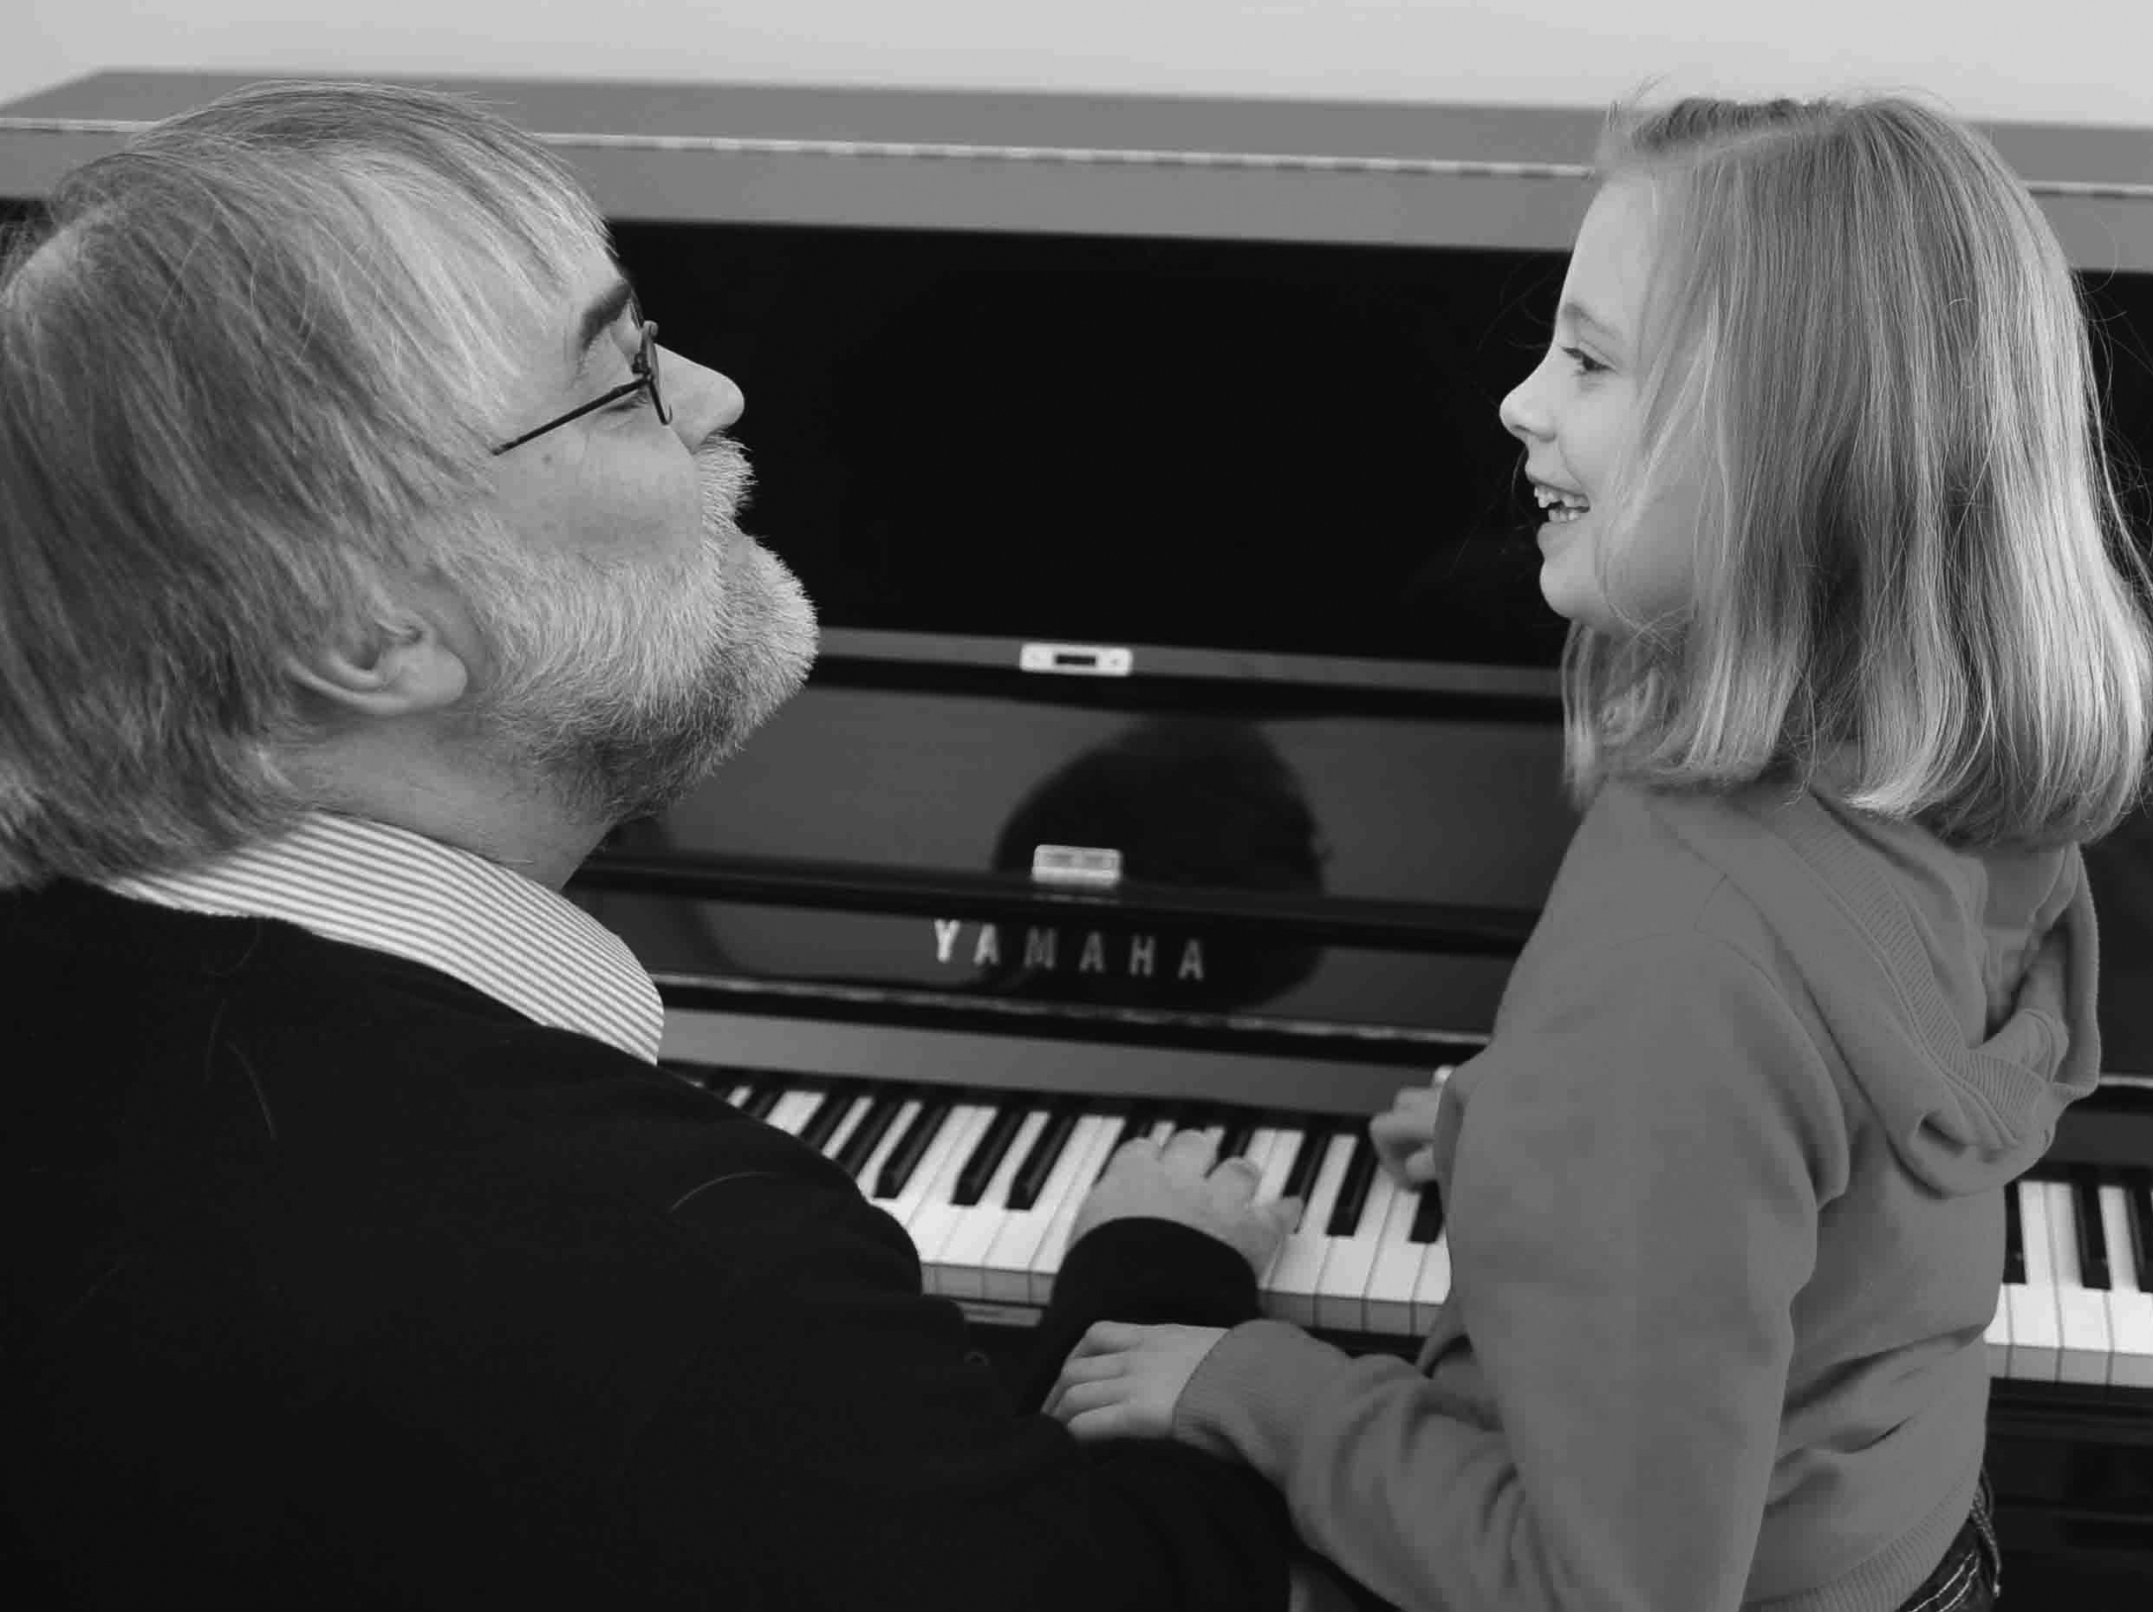

FIGURE 6. Romy and Adam share a musical joke (image © 2010 Evangelos Himonides).

When we started working together, six years ago, mistakes and misunderstandings occurred all too frequently since, as it turned out, there were very few pieces that Romy would tolerate: for example, the theme from Für Elise (never the middle section); the Habanera from Carmen; and some snippets from ‘Buckaroo Holiday’ (the first movement of Aaron Copland’s Rodeo). Romy’s acute neophobia meant that even one note of a different piece would evoke shrieks of fear-cum-anger, and the session could easily grow into an emotional conflagration.

So gradually, gradually, over weeks, then months, and then years, I introduced new pieces – sometimes, quite literally, at the rate of one note per session. On occasion, if things were difficult, I would even take a step back before trying to move on again the next time. And, imperceptibly at first, Romy’s fears started to melt away. The theme from Brahms’s Haydn Variations became something of an obsession, followed by the slow movement of Beethoven’s Pathetique sonata. Then it was Joplin’s The Entertainer, and Rocking All Over the World by Status Quo.

Over the six years, Romy’s jigsaw box of musical pieces – fragments ranging from just a few seconds to a minute or so in length – has filled up at an ever-increasing rate. Now it’s overflowing, and it’s difficult to keep up with Romy’s mercurial musical mind; mixing and matching ideas in our improvised sessions, and even changing melodies and harmonies so they mesh together, or to ensure that my contributions don’t!

As we play, new pictures in sound emerge and then retreat as a kaleidoscope of ideas whirls between us. Sometimes a single melody persists for fifteen minutes, even half an hour. For Romy, no matter how often it is repeated, a fragment of music seems to stay fresh and vibrant. At other times, it sounds as though she is trying to play several pieces at the same time – she just can’t get them out quickly enough, and a veritable nest of earworms wriggle their way onto the piano keyboard. Vainly I attempt to herd them into a common direction of musical travel.

So here I am, sitting at the piano in Roehampton, on a Sunday morning in mid-November, waiting for Romy to join me (not to be there when she arrives is asking for trouble). I’m limbering up with a rather sedate rendition of the opening of Chopin’s Etude in C major, Op. 10, No. 1 when I hear her coming down the corridor, vocalizing with increasing fervor. I feel the tension rising, and as her father pushes open the door, she breaks away from him, rushes over to the piano and, with a shriek and an extraordinarily agile sweep of her arm, elbows my right hand out of the way at the precise moment that I was going to hit the D an octave above middle C. She usurps this note to her own ends, ushering in her favorite Brahms-Haydn theme. Instantly, Romy smiles, relaxes and gives me the choice of moving out of the way or having my lap appropriated as an unwilling cushion on the piano stool. I choose the former, sliding to my left onto a chair that I’d placed earlier in readiness for the move that I knew I would have to make.

I join in the Brahms, and encourage her to use her left hand to add a bass line. She tolerates this up to the end of the first section of the theme, but in her mind she’s already moved on, and without a break in the sound, Romy steps onto the set of A Little Night Music, gently noodling around the introduction to Send in the Clowns. But it’s in the wrong key – G instead of E flat – which I know from experience means that she doesn’t really want us to go into the Sondheim classic, but instead wants me to play the first four bars (and only the first four bars) of Schumann’s Kleine Studie Op. 68, No. 14. Trying to perform the fifth bar would, in any case, be futile since Romy’s already started to play … now, is it I am Sailing or O Freedom? The opening ascent from D through E to G could signal either of those possibilities. Almost tentatively, Romy presses those three notes down and then looks at me and smiles, waiting, and knowing that whichever option I choose will be the wrong one. I just shake my head at her and plump for O Freedom, but sure enough Rod Stewart shoves the Spiritual out of the way before it has time to draw a second breath.

From there, Romy shifts up a gear to the Canon in D – or is it really Pachelbel’s masterpiece? With a deft flick of her little finger up to a high A, she seems to suggest that she wants Streets of London instead (which uses the same harmonies). I opt for Ralph McTell, but another flick, this time aimed partly at me as well as the keys, shows that Romy actually wants Beethoven’s Pathetique theme – but again, in the wrong key (D). Obediently I start to play, but Romy takes us almost immediately to A flat (the tonality that Beethoven originally intended). As soon as I’m there, though, Romy races back up the keyboard again, returning to Pachelbel’s domain. Before I’ve had time to catch up, though, she’s transformed the music once more; now we’re hearing the famous theme from Dvorak’s New World Symphony.

I pause to recover my thoughts, but Romy is impatiently waiting for me to begin the accompaniment. Two or three minutes into the session, and we’ve already touched on twelve pieces spanning 300 years of Western music and an emotional range to match. Yet, here is a girl who in everyday life is supposed to have no ‘theory of mind’ – the capacity to put yourself in other people’s shoes and think what they are thinking. Here is someone who is supposed to lack the ability to communicate. Here is someone who functions, apparently, at an 18-month level. But I say here is a joyous musician who amazes all who hear her. Here is a girl in whom extreme ability and disability coexist in the most extraordinary way. Here is someone who can reach out through music and touch one’s emotions in a profound way. If music is important to us all, for Romy it is truly her lifeblood.

How did Romy, severely learning disabled, become such a talented, if idiosyncratic, musician? In my view, it was her early inability to process language, in tandem with her inability to grasp the portent of many everyday sounds, that enhanced her ability to process all sounds in a musical way. The two were inextricably linked. Indeed, without the former, we can surmise that the latter would never have developed.
Romy has AP, meaning that for her, as we have seen, her mental images of musical sounds are distinct with regard to pitch. Hence, every note on the piano is instantly recognizable. But more than this, for Romy, each pitch provides a stable point of reference in a capricious world. And it’s not just notes on the piano that function for Romy in this way. In her mind, each of the notes in any piece of music sounds distinct. While, for most of us, musical sounds pass by unremarkably in perceptual terms, for Romy, different notes, different chords, can affect her profoundly: an E flat major harmony can make her quiver with excitement, for example, while G7 can make her cry.
In itself, though, absolute pitch is insufficient to make an exceptional musician; that takes at least 7,000 hours of practice (Sloboda, Davidson, Howe, and Moore 1996). How, then, did Romy acquire her musical skills? Like many autistic children early in life, she developed an obsession. In her case this was a small electronic keyboard, whose notes lit up in the sequence needed to play one of a number of simple tunes. As far as Romy was concerned, this musical toy was one of only a few things with which she could meaningfully interact, and whose logic she could understand, and she spent hundreds of hours playing with it. The keyboard was comfortingly predictable in comparison to with any human being – even her devoted family, whose language and behavior differed subtly from one occasion to another, as all interaction engagement does. The keyboard, though, invariably responded to Romy in the same way. Whenever she pressed a particular key, it always sounded the same as it did a before. Here was something in the environment that Romy could predict and control.
And so, through countless hours of self-directed exploration as a toddler, Romy discovered where all the notes (whose sounds she could hear in her head) are on the keyboard. Today, as a teenager, for Romy to play the piano merely requires her to hear a tune in her head (available to her through the internal library of songs, stored as series of absolute auditory images) and play along with it, pressing down the correct keys in sequence as their pitches sound in her head. And this approach works not only for music. As we noted above, she will reproduce the sounds of the jet engines of planes as they descend towards Heathrow Airport, for example, and she unhesitatingly copies any ringtones that interrupt her piano lessons.
AP can have other consequences for children on the autism spectrum too. The absolute representation of sounds in their heads appears to fuel musical imagination in a way that is more vivid, more visceral even, than the relative memory of intervals alone. And, although formal research is yet to be undertaken, the anecdotal accounts of parents and teachers suggest that earworms are widespread; evidenced most obviously in some children’s incessant vocalizing of melodic fragments. With minds full of tunes that seem to be playing the whole time, external sounds can be at best superfluous and at worst an irritation, as the following account of a session with Freddie, then eleven years old, shows.

Freddie – the silent musician

‘Why’s he doing that?’ Freddie’s father, Simon, sounded more than usually puzzled by the antics of his son.

After months of displacement activity, Freddie was finally sitting next to me at the piano, and looked as though this time he really were about to play. A final fidget and then his right hand moved towards the keys. With infinite care, he placed his thumb on middle C as he had watched me do before – but without pressing it down. Silently, he moved to the next note (D), which he feathered in a similar way, using his index finger, then with the same precision he touched E, F and G, before coming back down the soundless scale to an inaudible C.

I couldn’t help smiling.

‘Fred, we need to hear the notes!’

My comment was rewarded with a deep stare, right into my eyes. Through them, almost. It was always hard to know what Freddie was thinking, but on this occasion he did seem to understand and was willing to respond to my request, since his thumb went back to C. Again, the key remained un-pressed, but this time he sang the note (perfectly in tune), and then the next one, and the next, until the five-finger exercise was complete.

In most children (assuming that they had the necessary musical skills), such behavior would probably be regarded as an idiosyncratic attempt at humor or even mild naughtiness. But Freddie was being absolutely serious and was pleased, I think, to achieve what he’d been asked to do, for he had indeed enabled me to hear the notes!

He stared at me again, evidently expecting something more, and without thinking I leant forward.

‘Now on this one, Fred’, I said, touching C sharp.

Freddie gave the tiniest blink and a twitch of his head, and I imagined him, in a fraction of a second, making the necessary kinesthetic calculations. Without hesitation or error, he produced the five-finger exercise again, this time using a mixture of black and white notes. Each pressed silently. All sung flawlessly.

And then, spontaneously, he was off up the keyboard, beginning the same pentatonic pattern on each of the twelve available keys. At my prompting, Freddie re-ran the sequence with his left hand – his unbroken voice hoarsely whispering the low notes.

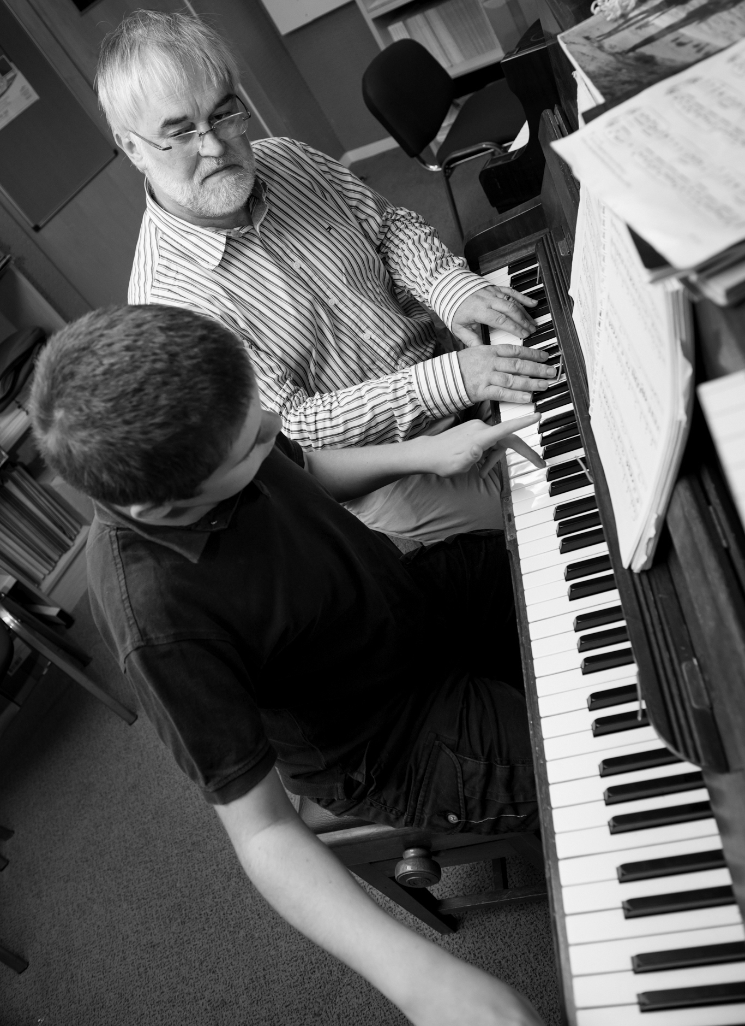

FIGURE 7. Freddie picks out a note on the piano (image © 2012 The University of Roehampton).

So logical. Why bother to play the notes if you know what they sound like already?

So apparently simple a task, and yet … such a difficult feat to accomplish: the whole contradiction of autism crystallized in a few moments of music making.

As I later said to Freddie’s father, if I had wanted to teach a ‘neurotypical’ child to do what his son had achieved with little or no apparent effort, it would probably have taken many lessons, and hundreds of hours of practice for the pupil to master the relationship between the Western tonal system and the asymmetrical (yet regular) layout of the piano keyboard. Yet Freddie had done it merely by watching and listening to what I had done, attending to the streams of notes flowing by, extracting the implicit rules of Western musical syntax, and using these to create patterns of sounds anew. The crucial point is that I had never played the full sequence of scales to Freddie that he subsequently produced. He had worked out the necessary structures intuitively, merely through exposure to music.

Conclusion

In this chapter, we have seen how some children on the autism spectrum appear to have aural imaginations that are rooted in processing a range of everyday sounds and even speech in a musical way. The way they perceive, remember, and imagine sounds has a high level of intensity born of their sense of AP. This enables them to play by ear – a skill that is often acquired entirely through their own efforts and that typically first manifests itself in the early years. But more than this, for Freddie, for Romy, and for many other children on the autism spectrum, music may be the key not only to aesthetic fulfillment, but also to communication, shared attention, and emotional understanding. It can do this because it is a language built not on symbolic meaning but on repetition; on order and on predictability in the domain of sound. With musically empathetic adults with whom to interact, this love of pattern – insistence, even – need not restrict the children’s auditory imaginations but can emancipate them, through the capacity to understand musical structure and the rules of the generative grammars through which melodies, harmonic sequences, and rhythms are created afresh.

References

Bishop, D., and K. Mogford-Bevan. 1993. Language Development in Exceptional Circumstances. Hove: Psychology Press.
Brandt, A., M. Gebrian, and L. R. Slevc. 2012. Music and Early Language Acquisition. Frontiers in Psychology 3. doi:10.3389/fpsyg.2012.00327.
DePape, A.-M. R., G. B. C. Hall, B. Tillmann, and L. J. Trainor. 2012. Auditory Processing in High-Functioning Adolescents with Autism Spectrum Disorder. Plos ONE 7 (9): e44084. doi:10.1371/journal.pone.0044084.
Fay, W. H. 1967. Childhood Echolalia. Folia Phoniatr Logop 19 (4): 297-306. doi:10.1159/000263153.
Fay, W. H. 1973. On the Echolalia of the Blind and of the Autistic Child. Journal of Speech and Hearing Disorder 38 (4): 478. doi:10.1044/jshd.3804.478.
Gaver, W. W. 1993. What in the World Do We Hear?: An Ecological Approach to Auditory Event Perception. Ecological Psychology 5 (1): 1-29. doi:10.1207/s15326969eco0501_1.
Lamont, A. 2008. Young Children's Musical Worlds: Musical Engagement In 3.5-Year-Olds. Journal of Early Childhood Research 6 (3): 247-261. doi:10.1177/1476718x08094449.
Lecanuet, J.-P.. 1996. Prenatal Auditory Experience. In Musical Beginnings, 3-34. Oxford: Oxford University Press.
Malloch, S., and C. Trevarthen. 2009. (Eds) Communicative Musicality: Exploring the basis of Human Companionship. New York, NY: Oxford University Press, USA.
Masataka, N. 2007. Music, Evolution and Language. Developmental Science 10, no. 1: 35-39.
McEvoy, R. E., K. A. Loveland, and S. H. Landry. 1988. The Functions of Immediate Echolalia in Autistic Children: A Developmental Perspective. Journal of Autism and Developmental Disorders 18 (4): 657-668. doi:10.1007/bf02211883.
Mcglone-Dorrian, D., and R. E. Potter. 1984. The Occurrence of Echolalia in Three Year Olds' Responses to Various Question Types. Communication Disorders Quarterly 7 (2): 38-47. doi:10.1177/152574018400700204.
Miller, L. 1989. Musical Savants: Exceptional Skill and Mental Retardation. Hillsdale, NJ: Laurence Erlbaum.
Mills, A. 1993. Visual Handicap. In Language Development in Exceptional Circumstances edited by D. Bishop and K. Mogford. Hove: Psychology Press, 150-164.
Norman-Haignere, S., N. G. Kanwisher, and J. H. McDermott. 2015. Distinct Cortical Pathways for Music and Speech Revealed by Hypothesis-Free Voxel Decomposition. Neuron 88 (6): 1281-1296. doi:10.1016/j.neuron.2015.11.035.
Ockelford, A. 2005. Repetition in Music: Theoretical and Metatheoretical perspectives. Farnham: Ashgate.
Ockelford, A. 2009. In the Key of Genius: The Extraordinary Life of Derek Paravicini. London: Random House.
Ockelford, A. 2013. Applied Musicology: Using Zygonic Theory to Inform Music Education, Therapy, and Psychology Research. New York, NY: Oxford University Press.
Ockelford, A. 2017. Comparing Notes: How We Make Sense of Music. London: Profile Books.
Patel, A. D. 2012. Language, Music, and the Brain: A Resource-Sharing Framework. In Language and Music as Cognitive Systems edited by P. Rebuschat, M. Rohmeier, J. A. Hawkins, and I. Cross. Oxford: Oxford University Press, 204-223.
Prizant, B. M. and J. F. Duchan. 1981. The Functions of Immediate Echolalia in Autistic Children. Journal of Speech and Hearing Disorder 46 (3): 241. doi:10.1044/jshd.4603.241.
Reese, A. 2014. The Effect of Exposure to Structured Musical Activities on Communication Skills and Speech for Children and Young Adults on the Autism Spectrum. Unpublished PhD thesis, University of Roehampton, London.
Sloboda, J. A., J. W. Davidson, M. J. Howe, and D. G. Moore. 1996. The Role of Practice in the Development of Performing Musicians. British journal of psychology 87, no. 2: 287-309.
Stalinski, S. M., and E. G. Schellenberg. 2010. Shifting Perceptions: Developmental Changes in Judgments of Melodic Similarity. Developmental Psychology 46 (6): 1799-1803. doi:10.1037/a0020658.
Sterponi, L., and J. Shankey. 2013. Rethinking Echolalia: Repetition as Interactional Resource in the Communication of a Child with Autism”. Journal of Child Language 41 (02): 275-304. doi:10.1017/s0305000912000682.
Takeuchi, A. H., and S. H. Hulse. 1993. Absolute Pitch. Psychological bulletin 113, no. 2: 345.
Treffert, D. 2009. The Savant Syndrome: An Extraordinary Condition. A Synopsis: Past, Present, Future. Philosophical Transactions of The Royal Society B: Biological Sciences 364 (1522): 1351-1357. doi:10.1098/rstb.2008.0326.
Vamvakari, T. 2013. My Child and Music: A Survey Exploration of the Musical Abilities and Interests of Children and Young People Diagnosed with Autism Spectrum Conditions. Unpublished Master’s Thesis, University of Roehampton, London.
Voyajolu, A., and A. Ockelford. 2016. Sounds of Intent in The Early Years: A Proposed Framework of Young Children’s Musical Development. Research Studies in Music Education 38 (1): 93-113. doi:10.1177/1321103x16642632.

http://blog.oup.com/2012/12/music-proxy-language-autisic-children/
http://www.huffingtonpost.com/adam-ockelford/autism-genius_b_4118805.html

