Draft 1.4 14.2.11

Music education and therapy for children and young people with cognitive impairments: reporting on a decade of research

Adam Ockelford and Kyproulla Markou

Introduction

A little over a decade ago, the first author set out a position paper that considered the place of music in the education of children and young people with severe or profound cognitive impairments (Ockelford, 2000). A number of issues were identified, including a dearth of knowledge as to the music provision that was made for these pupils and students. There was a perception, nonetheless, that music-pedagogical thinking and practice had largely neglected learners with such levels of disability, and a belief that music therapy had evolved to fill the void – often substituting for music education rather than complementing it. As a consequence, there was a lack of conceptual clarity as to what should reasonably constitute music education for those with severe or profound levels of learning disability as opposed to what could appropriately be regarded as falling within the remit of music therapy, and no clear idea of how education and therapy were related in this context.

The scant evidence that was available – a few references in the literature and informal observation of practice in schools – suggested that the content of music lessons and therapy sessions were likely to be similar in content, and that the difference between them probably lay in the teacher’s or therapist’s approach. It seemed that music therapy tended to promote the notion of wellbeing among clients more strongly through adopting a more child-centred approach, whereas music education laid a greater emphasis on fostering the development of skills, knowledge and understanding, through a combination of internally and externally determined goals. (It was suggested that a third category, ‘training’, was driven entirely by extrinsic factors.)

Research was proposed that would:

- investigate what music provision was made for pupils and students with learning difficulties in the England;
- map the musical development of children and young people with severe or profound learning difficulties; and
- elucidate the relationship between education and therapy for this group, with a particular focus on issues such as the locus of control and wellbeing.

This chapter reports on progress against these objectives.

Provision

The PROMISE research project was set up to investigate what music provision was being made for children and young people with learning difficulties in special schools in England (Welch, Ockelford and Zimmermann, 2001; Ockelford, Welch and Zimmermann, 2002). Although the work was to be undertaken in England, the research team believed that the findings would have wider relevance, since there was no research evidence, or indications in policy or curricular documentation, to suggest that provision was significantly more advanced elsewhere. In total, data from 52 special schools were obtained.

Curriculum

The research shows that, at the turn of the 21st century, there appears to have been no common music curriculum in place for pupils with severe or profound cognitive impairments, references to the framework theoretically offered by the English National Curriculum notwithstanding. Indeed, it seems that music education provision for young people with complex needs in England was characterised by diversity and idiosyncrasy. In some cases, approaches that were developed in the context of the early years appeared to have been extended to later phases – on account, no doubt, of pupils’ limited levels of functional development.

Shortly after the PROMISE report appeared, the UK Government, through the then Qualifications and Curriculum Authority (QCA), published the so-called ‘P-Levels’, which were intended to assist teachers in enabling their pupils with learning difficulties to access a broad and balanced curriculum (including music). However, as we shall see, the ‘P-Level’ for music was flawed in its conception, and observations undertaken as part of the Sounds of Intent project (see below) suggest that it has had little practical impact on the design or delivery of the music curriculum. Rather, teachers have learnt to report their pupils’ musical experiences, responses and actions against a set of criteria that can at best be described as arbitrary in music-developmental terms.

Resources

The PROMISE research (supported by an analysis of a sample of 50 subsequent Ofsted inspection reports, 2000–2005; see Ockelford, 2008) suggested that the resources available for the music education of many children and young people with severe or profound learning difficulties were limited – a deficiency that must inevitably have constrained the range of school-based musical experiences that were available to this generation of pupils and students. For example, the prevalence of untuned percussion instruments could only have reinforced the conceptualisation of much of the music curriculum within an early years framework, while the domination of ‘domestic’ music technology mitigated against pupils’ active engagement in musical activities. Subsequent observation of a wide range of schools through the Sounds of Intent project suggests that items of handheld percussion still tend to fill instrument trays, albeit with examples from a broader diversity of cultures that are now more readily available to teachers. However, specialist music and sound technology does appear to be in more general use than a decade ago, particularly in the context of multisensory environments.

Music in the wider curriculum

The PROMISE research and the subsequent Ofsted reports (up to 2005) indicated that the use of music as a medium for the delivery of the wider curriculum – as an agent to enhance learning throughout the school day – was highly valued and widespread in special schools making provision for pupils with learning difficulties. However, there were no indications that music was systematically conceptualised in this role, nor that general education that used music as a device to promote other learning was coherently linked to music education per se. Yet commonsense suggests that, for pupils whose perception of the world is likely to be fragmented and confusing, a joined-up approach could only have benefited learning and development. Subsequent evidence, for example, from the second author’s PhD study (Markou, 2010), and that of Cheng (2010), as well as from the Sounds of Intent project, suggests that the same position holds true today.

External links

The PROMISE research suggested that there were strong links with the wider musical community, and that a good deal of activity was taking place that was reckoned by those involved to have much intrinsic merit for the pupils and students concerned, despite few of the staff having any special training to work with young people with special needs. Moreover, external links seem to have arisen opportunistically rather than strategically, and there is no evidence, either in the PROMISE research or in the later sample of Ofsted reports (Ockelford, 2008), that any attempts had been made to relate special events to day-to-day music curricula. Again, evidence from Cheng (2010), suggests that a similar picture may still pertain.

Gauging attainment and progress

The PROMISE research found that music coordinators found it easier to conceptualise extra-musical outcomes to musical activity with pupils with learning difficulties than purely musical attainment and progress. This anomaly was echoed in the comments made by head teachers in relation to music’s perceived wider benefits and in the tendency of the Ofsted to focus on the description and analysis of extra-musical (as opposed to musical) activity. The Sounds of Intent project (described below) was set up to address this issue, which the researchers considered to lie at the heart of many of the problems associated with music education provision for children and young people with cognitive impairments. It was clear that teachers working in special schools had no sense of the music-developmental paths that their pupils and students were likely to follow, and so had no context in which to assess what they observed and only a limited conception of what ‘progress’ might mean. Without either of these building blocks in being in place, curriculum design inevitably tended to be ad hoc too.

Music Therapy

The provision of music therapy varied considerably across the schools in the PROMISE sample. It was reported as being provided on site by 36% of schools, while 19% were aware of some pupils receiving music therapy outside. Although two schools reported offering music therapy to all their pupils, on average, the number of pupils receiving this service was small, equating only to around 2% of the population of children and young people with severe or profound learning difficulties. All the therapists worked with individual pupils, with some undertaking additional work with up to four children or young people at a time, and three taking larger groups.

With regard to the musical content of the sessions, one therapist used improvised music exclusively, five improvised most of the time and two improvised and used established repertoire in equal measure. As to the style of this repertoire, half the therapists reported using nursery rhymes; two also used folksongs; two, pieces that they had composed; one, pop songs; and one, classical pieces. Only one therapist used recorded music in sessions.

In relation to gauging progress, the therapists gave detailed responses that were largely centred on communication, such as, ‘eye contact’, ‘vocalisation’, ‘language development’, ‘ability to express emotions through playing’, ‘awareness of others’, and ‘turn-taking’. They also mentioned ‘increasing confidence’, ‘enjoyment’, ‘increased attention span’ and ‘anticipation of sessions’. These criteria were in many cases identical to those used by music coordinators and head teachers to assess general progress made through music. Other school staff identified similar benefits of music therapy, including various aspects of communication (‘developing eye contact’, ‘non-verbal … communication’, ‘increasing vocalisation and pre-verbal skills’, ‘developing interpersonal expressive communication’, and ‘turn-taking’) and personal growth (‘development of listening and attention’, ‘increased awareness of self’, ‘confidence building’, ‘gaining freedom and independence’, and ‘making choices’). Again, these closely resembled music coordinators’ and head teachers’ comments made in relation to music education and progress in other areas.

In summary, the activities that went to make up music therapy sessions with pupils who have learning difficulties displayed a similar eclectic mix to those undertaken in the context of music education – apparently based largely on the personal beliefs and expertise of the practitioner concerned – and many of the perceived benefits of music therapy for pupils with cognitive impairments appeared to be very similar to those ascribed to music education. Yet there is no evidence that music-therapeutic activity or outcomes were typically used to inform other experiential or developmental programmes that involved music, or vice versa. Rather, for the few children who received music therapy, it appeared to be another strand of musical experience, running, at best, in parallel with others.

The relationship between music therapy and music education in provision for children and young people with severe or profound learning difficulties was subsequently the subject of detailed doctoral research by the second author, and is reported below.

Conclusion

The data gathered from the PROMISE research project and the sample of 50 Ofsted reports (2000–2005) indicated that there was a widespread recognition of the potential significance of music in the lives of pupils with cognitive impairments and of its power to assist in many areas of their learning and development. While the research was undertaken in England, anecdotal evidence and comments in the (very scarce) literature on the subject suggested that the findings summarised here may well have an international relevance.

While, in a few schools, there is evidence of structured music provision for different age groups, with fruitful links to the wider musical community, the general impression is one of relatively isolated professional activity in music, with schools taking an essentially pragmatic and eclectic approach in the absence of a commonly agreed framework, informed by empirical data, that would set out the musical development of children and young people with complex needs. The Sounds of Intent project sought to make good this shortfall.

Towards a model of music education for children and young people with learning difficulties

A key element in the first author’s position paper (Ockelford, 2000) was the proposition that music education for pupils and students with severe or profound learning difficulties should be conceived as having two distinct strands: activities that are undertaken primarily for their intrinsically musical value (‘education in music’) and those whose main function is to promote wider learning and development (‘education through music’). Both elements were grounded in the fact that hearing typically starts to develop in the human foetus four to three months before birth, and that, by the time they are born, babies may be particularly sensitive to sounds with which they have become familiar in the womb and prefer them to others: their mother’s voice, for example, the language she speaks and certain pieces of music (Lecanuet, 1996). Hence those with severe or profound learning difficulties, whose global development may be at a very early stage (as in the first few months of life), may nonetheless be able to process organised sounds relatively effectively: the musical mind may be intact amid a welter of other cognitive challenges. This has implications both for education in and through music.

Education in music: the Sounds of Intent project

The model of education in music first proposed in Ockelford (1998) had two components: ‘listening, responding and reflecting’ and ‘creating, causing and controlling sounds’. These evolved through substantial further research in what became the Sounds of Intent project (reported, for example, in Ockelford, Welch, Zimmermann and Himonides, 2005; Welch, Ockelford, Carter, Zimmermann and Himonides, 2009; Cheng, Ockelford and Welch, 2010; Ockelford, Welch, Jewell-Gore, Cheng, Vogiatzoglou, Himonides, 2011; Vogiatzoglou, Ockelford, Welch and Himonides, 2011). This sought to map musical development in children and young people with learning difficulties, and to provide a framework to inform the design of curricula suited to their special needs and abilities.

The Sounds of Intent research evolved partly in response to the ‘P-Levels’ (QCA, 2001), which outline early learning and attainment for pupils deemed to be functioning ‘below’ Level 1 on the English National Curriculum. They have eight levels, from ‘P1’ to ‘P8’, although the first three levels, corresponding to those with profound needs, are each subdivided into two: P1(i) and P1(ii), P2(i) and P2(ii), and P3(i) and P3(ii). These six descriptors are common across the whole curriculum, with different subject-focused examples added to illustrate some of the ways in which, it is suggested, staff may be able to identify attainment in different subject contexts. From level P4 to P8, the document states that ‘it is possible to describe pupils’ performance in a way that indicates the emergence of skills, knowledge and understanding in music’ – and examples are provided of how this can be achieved. It is claimed that teachers can use the eleven performance descriptions to decide which best fits a pupil over a period of time and in different contexts, and so track his or her ‘linear progress’ towards attainment at Level 1 of the National Curriculum.

However, the Sounds of Intent research team believed this claim to be unsustainable, and they identified a number of serious issues with the ‘P-Level’ for music. The main problem was the basis on which it was developed: it was unclear what evidence was used to underpin its construction, although it was said to ‘draw on effective practice across a range of schools’. But in the absence of a demonstrable, systematically derived, empirical foundation, we were left with an abiding sense of the anecdotal. In relation to music, for example, the following is an exhaustive list of the examples given for levels P1 to P3, in the order in which they occur.

startles at sudden noise
becomes still in a concert hall
becomes excited at repeated patterns of sounds
turns towards unfamiliar sounds
looks for the source of music
is encouraged to stroke the strings of a guitar
relaxes during certain pieces of music but not others
recognizes a favourite song
repeatedly presses the keys of an electronic keyboard instrument
taps piano keys gently and with more vigour
listens intently when moving across and through a sound beam
anticipates a loud sound at a particular point in a piece of music
taps, strokes, rubs or shakes an instrument to produce various effects

We could not imagine how these examples could possibly be thought to be representative when there was no mention (for example) of vocalisation or vocal interaction – widely considered to be the bedrock of early music-making and musical communication (see, for instance, Papoušek, 1996, p. 58; Trevarthen, 2002).

In contrast to the QCA’s approach, which attempted to extrapolate developmental concepts ‘downwards’ from the artificial sociological construct of the National Curriculum, the Sounds of Intent team adopted a bottom-up approach, working with a group of practitioners who were active in the field to develop shared interpretations of the different forms and levels of musical engagement that were observed among their pupils and students with severe or profound learning difficulties. Children’s and young people’s responses, actions and interactions were carefully noted and encapsulated in short descriptions. (Examples are shown in Table 1.)

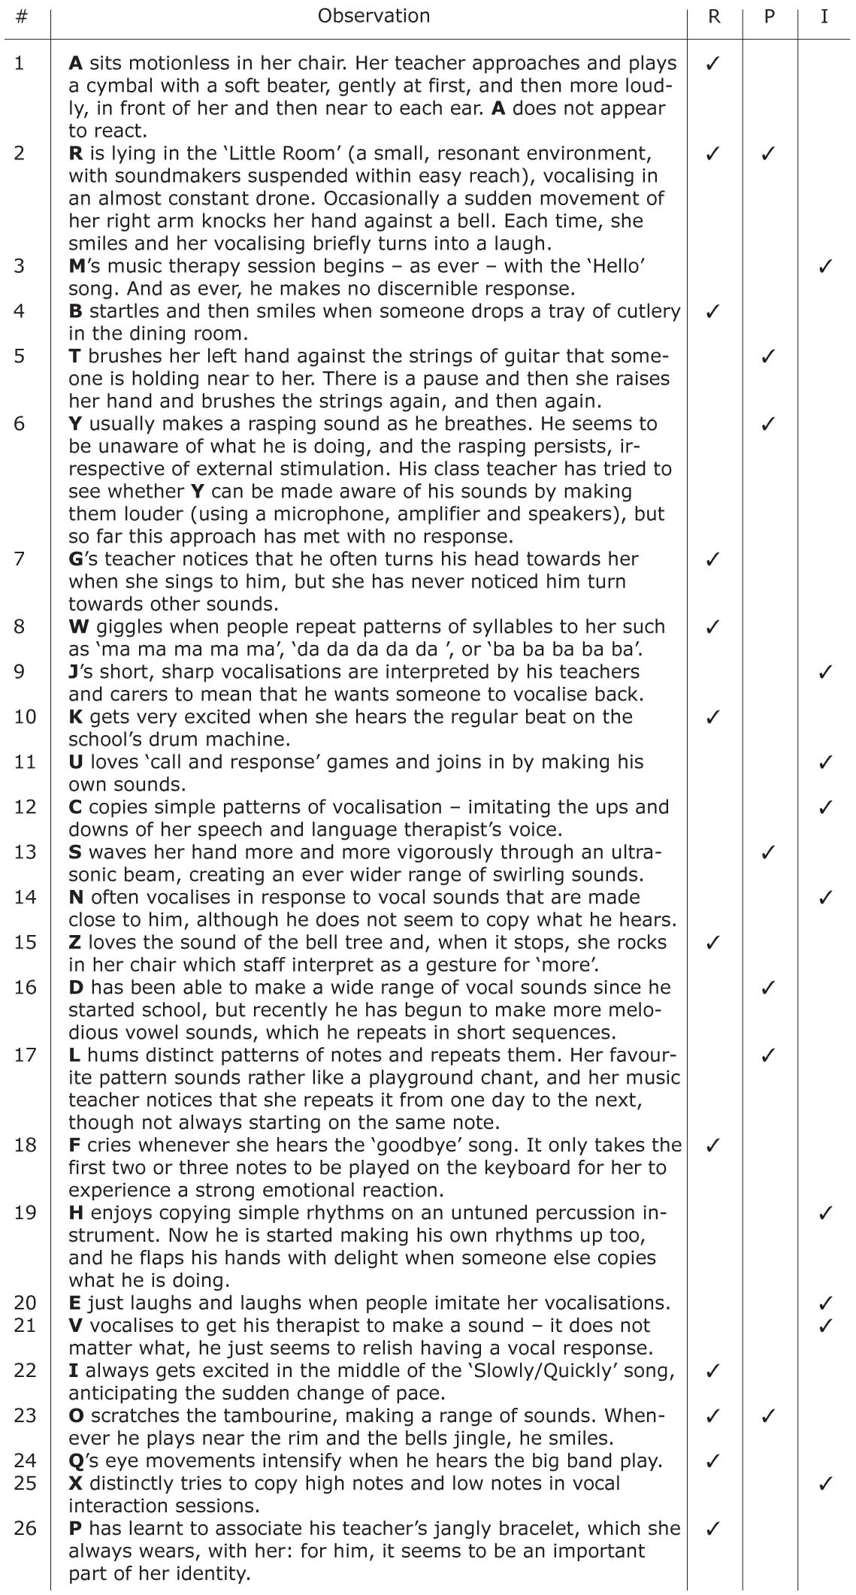

Table 1 Examples of musical engagement observed in children and young people with severe or profound learning difficulties.

It became evident that it would not be possible to conceptualise their musical development unidimensionally since, for example, a young person’s capacity for attending to sounds may well be more advanced than his or her ability to produce them. Therefore, at least two dimensions were required: ‘listening and responding’, for which the single term ‘reactive’ (‘R’) was adopted, and ‘causing, creating and controlling’, for which the label ‘proactive’ (‘P’) was used. In relation to the examples given above, 1, 2, 4, 7, 8, 10, 15, 18, 22, 23, 24 and 26 were considered to be entirely or predominantly ‘reactive’ and 2, 5, 6, 13, 16, 17 and 23, ‘proactive’. However, that left other observations (as in examples 3, 9, 11, 12, 14, 19, 20, 21 and 25) in which listening to sounds and making them occurred in the context of participation with others. It was decided that this form of activity merited the status of a separate dimension, which was termed ‘interactive’ (‘I’). (See Table 1.) While the three dimensions R, P and I have areas of conceptual overlap, the important thing was that they were deemed by practitioners to be meaningful and useful in terms of categorising the types of musical engagement that they observed.

Attempts were made to place examples such as those cited above along each of the three dimensions: (i) reactive (in response to another), (ii) proactive (initiating behaviour without an obvious external prompt), or (iii) interactive (with another). Their relative position of each within a dimension was based on its status a necessary developmental precursor or possible successor to another or others. For instance, it was evident that an awareness of sound (as in Example 2) must precede a differentiated response (as in Example 7), which in turn must precede the capacity to anticipate change (Example 22). This heuristic approach was necessary since the evidence available comprised snapshots of different children at various stages of development, rather than longitudinal data on the same children as they matured, which would have offered greater certainty as to the nature of developmental change. Taking a more exploratory tack, though, was deemed valid as a preliminary step for two reasons: first, since at that stage it was not yet clear what the appropriate data to collect would be; and second, since it was believed that meaningful longitudinal studies of children with complex needs would be likely to last for months if not years. However, it was felt that once an initial model had been developed, this could subsequently be used to inform longer-term empirical work, as well as being informed by it.

As potential sequences of stages of musical engagement emerged, they were mapped onto what is known of ‘typical’ early musical development (drawing on the established literature in this field, ranging, for example, from Moog, 1968/1976; Dowling, 1982 and Hargreaves, 1986 to Trehub, 1990, 2003; Fassbender, 1996; Lecanuet, 1996; Papoušek, 1996; Trevarthen, 2002 and Welch, 2006) as a way of benchmarking what was being proposed, but without imposing potentially inappropriate constraints, since it was not known just how relevant ‘usual’ development was to the way in which the musicality of children with complex needs evolves.

A third influence was Ockelford’s ‘zygonic’ theory of musical-structural cognition (for example, 2005, 2010) which seeks to explain how music makes intuitive sense through the (typically nonconscious) recognition of repetition and regularity in the domains of pitch and perceived time: the thinking being that, since such a capacity does not arise in people fully-fledged, it must evolve as a strand in musical development, implying that the theory may provide a useful way of conceptualising stages within that process of maturation.

A number of attempts were made to draw the three sources of evidence (observations, the findings of ‘mainstream’ child psychology and zygonic theory) into a single coherent music-developmental framework for young people with complex needs. Different configurations were proposed, discussed and systematically trialled in the field, with practitioners offering qualitative feedback, supplemented with quantitative data gathered by a research assistant. This information enabled the research team iteratively to refine the model, enabling it to capture a wider range of musical behaviours, and enhancing intra- and inter-domain consistency (Welch, Ockelford, Carter, Zimmermann and Himonides, 2009). Eventually, six fundamental levels of music processing capacity emerged, which offered both an intuitively satisfying and theoretically coherent scheme. These are set out in Table 2.

Level | Description | Core cognitive abilities
1 | Confusion and Chaos | None: no awareness of sound as a distinct perceptual entity
2 | Awareness and Intentionality | An emerging awareness of sound as a distinct perceptual entity and of the variety that is possible within the domain of sound
3 | Relationships, Repetition, Regularity | A growing awareness of the possibility and significance of relationships between the basic aspects of sounds
4 | Sounds Forming Clusters | An evolving perception of groups of sounds, and the relationships that may exist between them
5 | Deeper Structural Links | A growing recognition of whole pieces, and of the frameworks of pitch and perceived time that lie behind them
6 | Mature Artistic Expression | A developing awareness of the culturally determined ‘emotional syntax’ of performance (expressed, for example, through rubato and dynamics) that articulates the ‘narrative metaphor’ of a piece

Table 2 The six levels underpinning the Sounds of Intent framework (acronym ‘CIRCLE’).

Extending these six levels across the three domains of musical engagement that had been identified gave rise to the following ‘headlines’ or ‘level descriptors’ of reactivity, proactivity and interactivity (see Figure 1). These were arranged as 18 segments in circular form, which practitioners on the Sounds of Intent research team regarded as being the most appropriate metaphor for children’s development, ranging from the centre, with its focus on self, outwards, to increasingly wider communities of others.

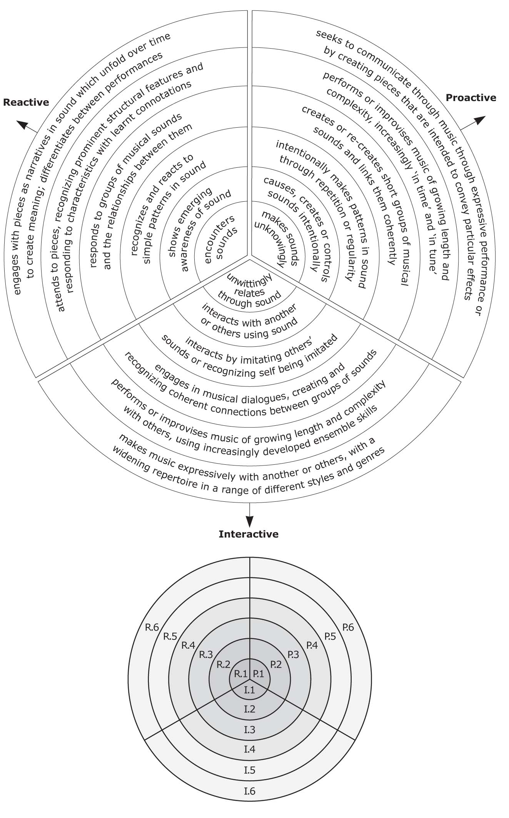

Figure 1 Visual representation of the Sounds of Intent framework.

For ease of reference, levels were ranked from 1–6, each of which could be preceded with an ‘R’, a ‘P’ or an ‘I’, to indicate, respectively, reactive, proactive or interactive segments. Each was broken down into four more detailed elements, as the examples in Table 3 show.

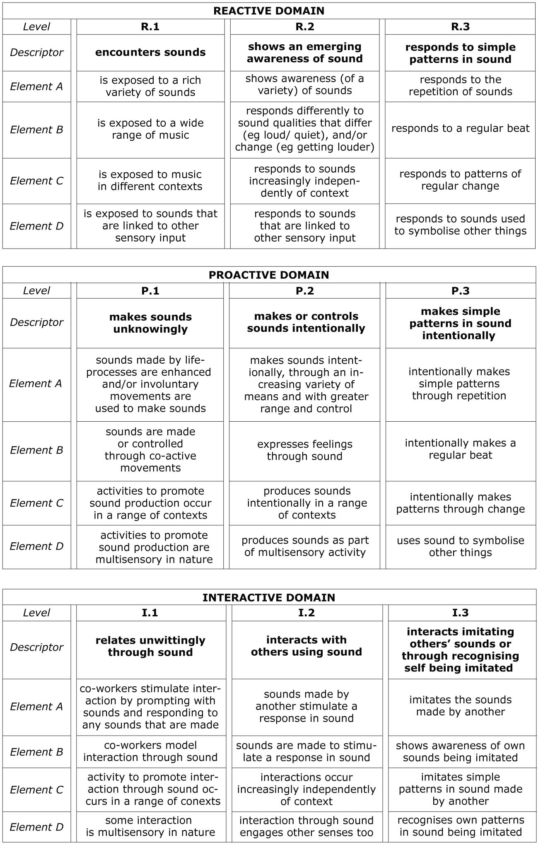

Table 3 Elements at Levels 1–3 in the reactive, proactive and interactive domains.

Although this table is regular in appearance, the way that the level descriptors and elements relate to each other within and between the reactive, proactive and interactive domains is complex. Level descriptors form a hierarchy whereby, within each domain, achievement at higher levels is dependent on the accomplishment of all those that precede. So, for example, in the interactive domain, I.4, ‘Engages in musical dialogues, creating and recognising coherent connections between groups of sounds’, could only occur following I.3, ‘Interacts by imitating other’s sounds or recognising self being imitated’ and (therefore) after accomplishing I.2 and I.1. Between domains, there is a broad flow of contingency that runs from reactive to proactive and then to interactive. For instance, in the proactive domain, intentionally making patterns in sound through repetition (P.3) depends on the capacity to recognise simple patterns in sound (R.3); while interacting with another or others using sound (I.2) relies on the ability to cause, create or control sounds intentionally (P.2), which in turn requires an awareness of sound (R.2). The pattern of contingencies that links the 72 elements is more intricate. Although in some cases there is a necessary connection between elements at different levels within domains (for example, a pupil could not engage in intentional repetition – P.3.A – before having the wherewithal to make a variety of sounds – P.2.B) and between them (for instance, imitating the sounds made by another – I.3.A – similarly requires functioning at the level of P.2.B), this is not always the case. It is perfectly conceivable that a child could intentionally make simple patterns through a regular beat (P.3.B), for example, before using sounds to symbolise particular people, places or activities (P.2.D). However, the research team felt that intricacies of this type were an inevitable consequence of the complicated nature of musical development: multi-layered and multi-stranded. At any given time, it was unlikely that the framework would indicate a pupil as being at a particular point on a developmental scale, but, rather, having a music-developmental profile, incorporating attainment at different levels in relation to a number of different elements.

Education through music

The second strand of music education for pupils and students with cognitive impairments proposed in the position paper (Ockelford, 2000) was education through music, in which it is used as a tool to promote learning and development in a variety of other areas. This notion was developed at some length in Ockelford (2008, pp. 113–145), in which four extra-musical domains of activity were identified, drawing on the findings of the PROMISE research:

- body awareness and movement,
- learning,
- language and communication, and
- social interaction.

Body awareness and movement

Children’s and young people’s awareness of their own physicality, and the control and coordination of a wider range of movements can be nurtured through playing instruments and other sound-makers. Whatever the movement required, the principle is that the pupil or student concerned will be motivated to move in order to produce a sound (implying that he or she is functioning in musical terms at Sounds of Intent Level 2 or above).

Music may also provide an ‘auditory frame of reference’ for movement, whereby the characteristics of a piece they are hearing influence, more or less specifically, accompanying actions. The strongest link between music and movement is found in rhythm, whereby regular changes in sound, which give the impression of a ‘pulse’, may stimulate a corresponding regularity in movement through the process of ‘entrainment’ (Clayton, Sager and Will, 2005). In the domain of pitch, a rise is widely considered to correspond to movement in an upward direction and vice versa. While this correspondence is generally conveyed through the more or less conscious efforts of teachers and others, and appears to be at least in part culturally determined (Zbikowski, 2002, p. 71), there is also some evidence that it occurs as a consequence of the natural way that thinking develops (Welch, 1991). Either way, it implies the activation of cross-modal connections in the mind (between sound and percepts in another domain), which the Sounds of Intent framework suggests may occur from Level 2 onwards.

Learning

Music and other organised sound can be used to promote pupils’ and students’ acquisition of skills, knowledge and understanding in a number of ways, including:

- using music and other structured auditory input to enhance sensory information obtained from the environment – for example, by systematically linking auditory to tactile, visual and other sensory experiences;
- promoting the direct transfer of perceptual and cognitive attributes from musical contexts to other spheres of activity – for example, memory (Overy, 1998) and concentration (Bunt, 1994, pp. 111ff);
- isolating selected qualities of sound and treating them as concepts to be manipulated in pursuit of educational goals beyond music – for example, sorting instruments on the basis of the materials from which they are made; and
- regarding pieces of music as potential sources of information about the cultures in which they were created – for example, learning something about Indonesian traditions through playing the gamelan.

Language and communication

Music and other organised sounds, in addition to speech, fulfil a range of symbolic functions in everyday life (such as TV theme tunes, the bells and gongs used in religious ceremonial, door chimes and the referee’s whistle in sport) – and sound symbols can be devised especially to augment or replace efforts at receptive or expressive communication (Ockelford, 2008, p. 132). For example, a series of sounding objects can function referentially as a kind of ‘auditory timetable’, informing pupils and students of which activities have been completed, and which are coming next.

Music shares common roots with verbal language in early development (Powers and Trevarthen, 2009), and at all stages of the human experience, the two are combined in the form of songs and chants. This affinity can be particularly useful in promoting communication and fostering its development among children who have learning difficulties. Music can provide the motivation to use language, and it can help to structure it, through its characteristic use of repetition (Ockelford, 2005).

Social interaction

Music has many different functions in life, many of which are social in nature (Hargreaves and North, 1997). Music sessions can offer a unique and secure framework through which many of the skills and disciplines of social interaction (such as listening to others, turn taking, and making a relevant contribution) can be experienced and developed. This is especially true for pupils and students with severe or profound learning difficulties, for whom the intricacies of verbal language and the subtle visual cueing that typically inform face-to-face communication may prove particularly challenging to discern and comprehend.

Music education, music therapy, and the role of wellbeing

The conceptual confusion between music education and music therapy for children and young people with cognitive impairments hinted at in Ockelford (2000) and unearthed in the course of the PROMISE project (Welch, Ockelford and Zimmermann, 2001), was echoed in subsequent research into the musicality of children and young people with septo-optic dysplasia (Pring and Ockelford, 2005) and retinopathy of prematurity (Ockelford and Matawa, 2009). Here some descriptions of the music therapy that was being offered seem to indicate that in reality music education was taking place. For example, a seven-and-a-half-year-old visually impaired autistic girl ‘works with her music therapist on learning the piano and also a variety of instruments’ (Ockelford, Pring, Welch and Treffert, 2006, p. 32).

Similar examples are sprinkled across the music-therapeutic literature from the last 40 years or so. For example, Nordoff and Robbins describe how some of their young clients learnt ‘new activities, new words, new music’ and became more responsive to other people (1971, p. 123), how a girl started to develop speech through music therapy (op. cit., pp. 30–31), and how music helped an autistic boy to develop independence skills (p. 105). Similarly, Postacchini, Borghesi, Flucher, Guida, Mancini, Nocentini, Rubin and Santoni (1993) relate how music therapy sessions with a five-year-old girl with ‘severe infantile regression’ were considered to improve her movement and use of vision, and assist her in moving from pre-symbolic to symbolic communication. Among the reasons that Bunt sets out for undertaking music therapy with a nine-year-old boy with learning difficulties are ‘to help develop auditory awareness and memory’ and ‘to help develop his ability to share’ (1994, p. 105). Similarly, Schwalkwijk (1994, pp. 79ff) discusses the potential role of music therapy in the stimulation of motor and cognitive skills.

But to what extent do these accounts accord with the definitions of music therapy offered by therapists themselves? Bruscia (1987, p. 47), for example, asserts that ‘Music therapy is a systematic process of intervention wherein the therapist helps the client to achieve health, using musical experiences and the relationships that develop through them as dynamic forces of change’. Bunt (1994, p. 8), in referring to this definition and others, concludes that ‘Music therapy is the use of organised sounds and music within an evolving relationship between client and therapist to support and encourage physical, mental, social and emotional well-being’. When these aims are compared with the descriptions of the music-therapeutic activities cited above, it is evident that some therapists working with children and young people with learning difficulties have diversified from fostering ‘well-being’ through music, and moved into educational areas such as promoting learning and development, for example (where, as we have seen, music can fulfil a range of functions).

A decade ago, Ockelford (2000) questioned why therapists should have become involved in educational activity. It seemed that potential factors included the unwillingness of those working in music education to work with those with severe or profound learning difficulties. Although, with the increasing inclusion of children and young people with disabilities in mainstream schools, one might have expected the position to have changed in the intervening period, the reality is that those with severest levels of intellectual impairment are still educated in special schools, where, the Sounds of Intent research suggests, there are still relatively few music-education specialists working.

The PROMISE research and the evidence of the Ofsted inspection reports (2000–2005) suggested that the overlap between the activities that constitute education in and through music and those that comprise music therapy, identified by Ockelford (2000), continues to exist. The second author’s doctoral research (Markou, 2010) tackled this issue head on. She tested the speculation, set out in Ockelford’s (2000) model, that the key difference lay in the teacher’s or therapist’s approach. The model had suggested that both music education and music therapy promote ‘wellbeing’, but that this was a more important feature of music therapy. Music education, on the other hand, was more focused on ‘development’ (of skills, knowledge and understanding). In parallel with this, therapy was conceived as having more client-centred, ‘internally’ determined goals, whereas effective music education was thought to balance ‘internally’ and ‘externally’ driven objectives.

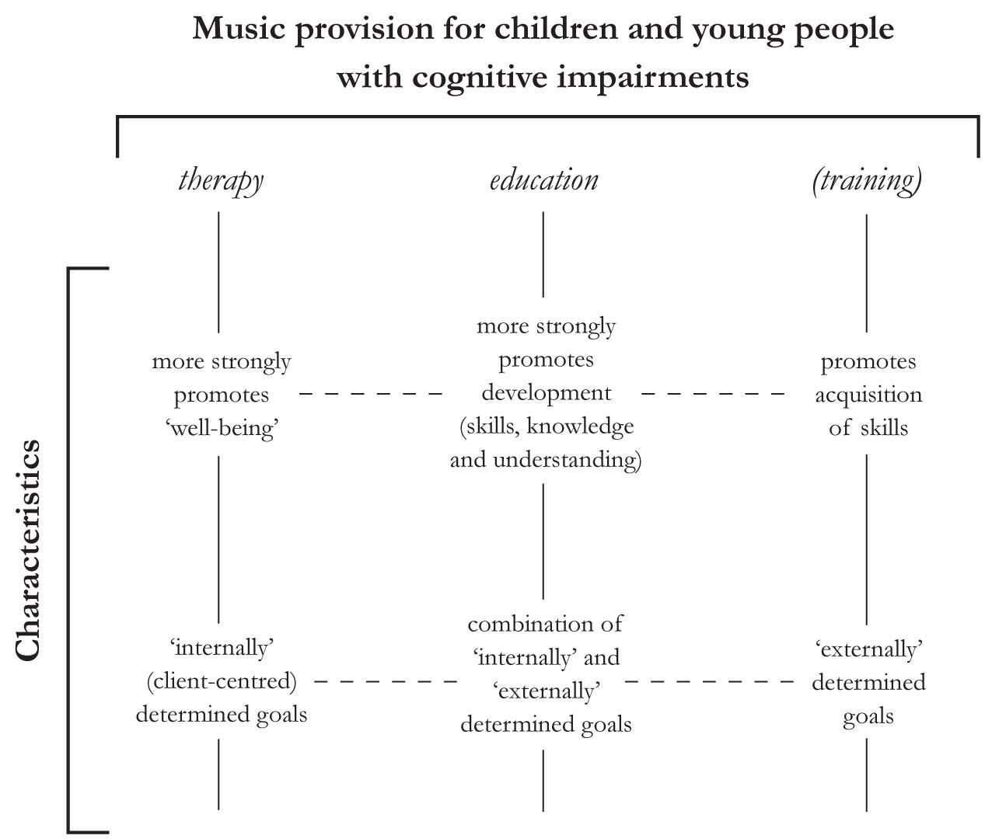

Figure 2 The purported link between music therapy and music education for children and young people with cognitive impairments (after Ockelford, 2000, p. 214).

To test this assertion, Markou asked an equal sample of teachers and therapists working in the field (N = 96) ‘To what extent does the child play a part in guiding your sessions/lessons? The permitted range of responses was from ‘1 = not at all’ to ’10 = completely’ set out on a Likert scale. The results were as follows:

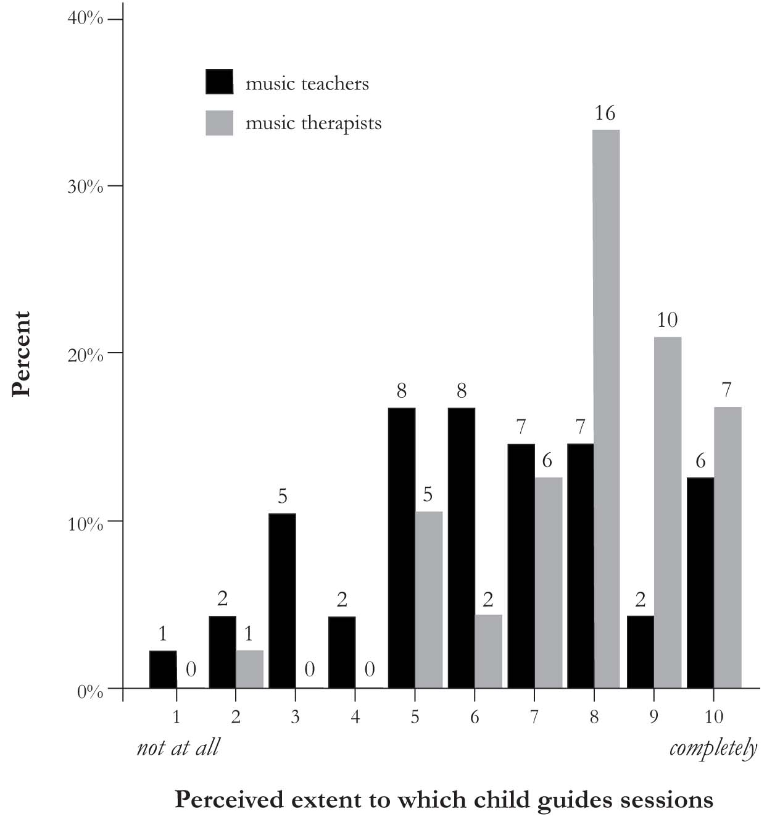

Figure 3 The extent to which children and young people are considered by therapists and teachers to determine the direction of sessions.

These data suggest that teachers and therapists do indeed tend to differ in the importance they attach to child-centredness. Teachers perceive themselves on average as being slightly more child-centred than not, but with a spread of responses across the entire spectrum (M = 6.23, SD = 2.37), whereas therapists believe themselves to be almost entirely child-centred in their work (M = 7.90, SD = 1.70). The difference is statistically significant, t(96) = –3.95, p < 0.001. These perceptions tie in with the declared content of the music lessons and therapy sessions, with the majority of teachers and therapists claiming to use both improvised and pre-composed songs and instrumental music; 13 teachers using only pre-composed instrumental music and 12, only pre-composed songs; and 14 therapists using only improvised instrumental music and 11, only improvised songs – differences that, again, are statistically significant, both for songs χ(2, N = 98) = 20.31, p < .001 and instrumental music χ(1, N = 98) = 24.27, p < .001.
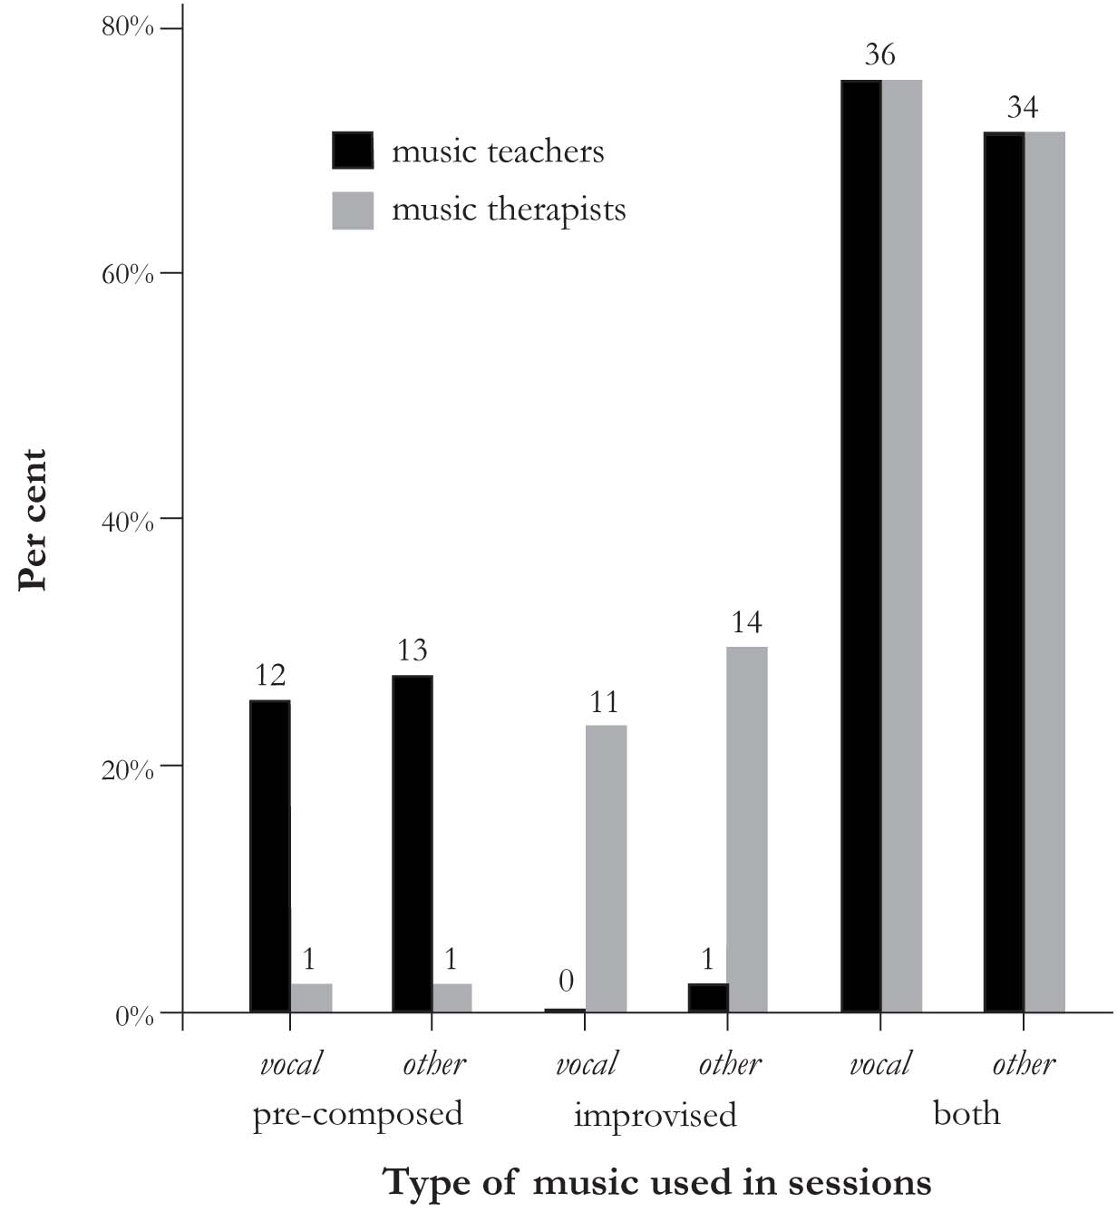

Figure 4 The proportion of improvised and pre-composed vocal and instrumental music that teachers and therapists report using.

Given the overlap, it is reasonable to ask whether aspects of education and therapy are inextricably linked in effective music provision for children and young people with severe or profound cognitive impairments. For example, one could argue that it would not be possible to engage in music therapy with such pupils and students without, at least to an extent, entering in to educational activity too, since how could they benefit from therapy without some pre-existing skills and understanding (presumably acquired through education, formal or informal)? And is it not reasonable – indeed desirable – to assume that, in many children and young people, skills and understanding will develop in the course of therapy sessions? It seems reasonable to argue that, the greater their technical proficiency, the more effectively children and young people will be able to express themselves in music, and the more likely they will be able to attain, Bunt’s state of wellbeing, albeit transiently. Conversely, it seems unimaginable that a child or young person could make educational progress unless he or she had or developed at least some sense of wellbeing in the course of engaging with the curriculum. Hence, is there not inevitably a therapeutic component in education too?

Conclusion

Looking back over the first decade of the 21st century, it is pleasing to note that significant progress has been made against the key research objectives set out in Ockelford (2000). The PROMISE report investigated the provision that was made for pupils and students with learning difficulties in the England – work that was updated through an analysis of relevant Ofsted reports (2000–2005) (Ockelford, 2008). The musical development of children and young people with severe or profound learning difficulties was mapped in great detail as the central focus of the Sounds of Intent project, through the collaboration of schools across the UK. Finally, the relationship between education and therapy for this group was elucidated through the second author’s doctoral work (Markou, 2010).

The authors very much hope that the next decade will see the move from research to impact, as we engage with others to ensure that the academic thinking outlined in this chapter and elsewhere is put to work to influence policy and practice in the field. We believe that the findings of the Sounds of Intent research, which is currently coming to fruition through the development of an interactive website, will be key, as it will be freely accessible to all practitioners: therapists, teachers, community musicians and parents. The information and resources this will make available, combined with its ease of use, should fill in many of the gaps identified in PROMISE research, enabling those working with children and young people with severe or cognitive impairments – music specialists and non-specialists alike – to offer a coherent music curriculum throughout school and beyond. The connection between music therapy and education remains as complex as ever, and continues to evolve as forces in the external environment change (see, for example, Darrow and Adamek, 2011; Jellison, 2011; McFerran and Elefant, 2011). Hopefully the Sounds of Intent framework will provide a common basis for planning and evaluation, while recognising that the priorities of delivery may differ. In this respect, it is interesting to observe how, in the last few years, the notion of ‘wellbeing’, which was previously felt to be the preserve of therapists, is now entering educational discourse much more widely (see, for example White, 2007), and it could be that provision for those with the most complex needs will prove a melting pot for new and welcome developments in this respect.

References

Bruscia, K. (1987) Improvisational Models of Music Therapy. Springfield, Illinois: Charles: C. Thomas.
Bunt, L. (1994) Music Therapy: An Art Beyond Words. London: Routledge.
Cheng, E. (2010) Musical Behaviours and Development of Children and Young People with Complex Needs: Three Longitudinal Case Studies, unpublished PhD dissertation, London: Institute of Education.
Cheng, E., Ockelford, A. and Welch, G. (2010) ‘Researching and developing music provision in special schools in England for children and young people with complex needs’, Australian Journal of Music Education, 2009(2), 27–48.
Clayton, M., Sager, R. and Will, U. (2005) ‘In time with the music: the concept of entrainment and its significance for ethnomusicology’, European Meetings in Ethnomusicology, 11, 3–142.
Darrow, A.-A. and Adamek, M. (2011) ‘Preparing for the future: music students with special educational needs in school and community life’, in G. McPherson and G. Welch (eds), The Oxford Handbook of Music Education, Oxford: Oxford University Press, (in press).
Dowling, J. (1982) ‘Melodic information processing and its development’, in D. Deutsch (ed.), The Psychology of Music, pp. 413–429, New York: Academic Press.
Fassbender, C. (1996) ‘Infants’ auditory sensitivity towards acoustic parameters of speech and music’, in I. Deliège and J. Sloboda, Musical Beginnings, pp. 56–87, Oxford: Oxford University Press.
Hargreaves, D. (1986) The Developmental Psychology of Music, Cambridge: Cambridge University Press.
Hargreaves, D. and North, A. (1997) The Social Psychology of Music, Oxford: Oxford University Press.
Jellison, J. (2011) ‘Inclusive music classrooms and programmes’, in G. McPherson and G. Welch (eds), The Oxford Handbook of Music Education, Oxford: Oxford University Press, (in press).
Lecanuet, J.-P. (1996) ‘Prenatal auditory experiencee’, in I. Deliège and J. Sloboda (eds), Musical Beginnings, pp. 3–34, Oxford: Oxford University Press.
Markou, K. (2010) The Relationship between Music Therapy and Music Education in Special School Settings: The Practitioners’ Views, unpublished PhD thesis, London: Roehampton University.
McFerran, K. and Elefant, C. (2011) ‘A fresh look at music therapy in special education’, in G. McPherson and G. Welch (eds), The Oxford Handbook of Music Education, Oxford: Oxford University Press, (in press).
Moog, H. (1968/1976) The Musical Experiences of the Pre-school Child (trans. C. Clarke). London: Schott.
Nordoff, P. and Robbins, C. (1971) Therapy in Music for Handicapped Children. London: Victor Gollancz.
Ockelford, A. (1998) Music Moves: Music in the Education of Children and Young People who are Visually Impaired and have Learning Disabilities. London: Royal National Institute of the Blind.
Ockelford, A. (2000) ‘Music in the education of children with severe or profound learning difficulties: Issues in current UK provision, a new conceptual framework, and proposals for research’, Psychology of Music, 28(2): 197–217.
Ockelford, A. (2005) Repetition in Music: Theoretical and Metatheoretical Perspectives. London: Ashgate.
Ockelford, A. (2008) Music for Children and Young People with Complex Needs, Oxford: Oxford University Press.
Ockelford, A. (2010) ‘Zygonic Theory: Introduction, Scope, Prospects’, Zeitschrift der Gesellschaft für Musiktheorie, 6(2), 91–172.
Ockelford, A. and Matawa, C. (2009) Focus on Music 2: Exploring the Musicality of Children and Young People with Retinopathy of Prematurity, London: Institute of Education.
Ockelford, A., Pring, L., Welch, G. and Treffert, D. (2006) Focus on Music: Exploring the Musical Interests and Abilities of Blind and Partially-Sighted Children with Septo-Optic Dysplasia, London: Institute of Education.
Ockelford, A., Welch, G., Jewell-Gore, L., Cheng, E., Vogiatzoglou, A. and Himonides, E. (2011) ‘Sounds of Intent, Phase 2: approaches to the quantification of music-developmental data pertaining to children with complex needs’, European Journal of Special Needs Education, (in press).
Ockelford, A., Welch, G. and Zimmermann, S. (2002) ‘Music education for pupils with severe or profound and multiple difficulties’, British Journal of Special Education, 29(4), 178–182.
Ockelford, A., Welch, G., Zimmermann, S. and Himonides, E. (2005) ‘Sounds of intent’: mapping, assessing and promoting the musical development of children with profound and multiple learning difficulties’, International Congress Series, 1282, 898–902.
Overy, K. (1998) Discussion Note: “Can music really ‘improve’ the mind?”, Psychology of Music, 26(1): 97–99.
Papoušek, H. (1996) ‘Musicality in infancy research: biological and cultural origins of early musicality’, in I. Deliège and J. Sloboda (eds), Musical Beginnings, pp. 37–55, Oxford: Oxford University Press.
Postacchini, P. L., Borghesi, M., Flucher, B., Guida, L., Mancini, M., Nocentini, P., Rubin, L. and Santoni, S. (1993). ‘A case of severe infantile regression treated by music therapy and explored in group supervision’, in M. Heal and T. Wigram (eds), Music Therapy in Health and Education, pp. 26–31, London: Jessica Kingsley.
Pring, L. and Ockelford, A. (2005) ‘Children with septo-optic dysplasia – musical interests, abilities and provision: the results of a parental survey’, British Journal of Visual Impairment, 23(2): 58–66.
Qualifications and Curriculum Authority (2001) Plannning, Teaching and Assessing the Curriculum for Pupils with Learning Difficulties, London: QCA.
Schwalkwijk, F. (1994) Music and People with Developmental Disabilities, London: Jessica Kingsley.
Trehub, S. (1990) ‘The perception of musical patterns by human infants: the provision of similar patterns by their parents’, in M. Berkley and W. Stebbins (eds), Comparative Perception; Vol. 1, Mechanisms, pp. 429–459, New York: Wiley.
Trehub, S. (2003) Toward a developmental psychology of music, Annals of the New York Academy of Sciences, 999, 402-413
Trevarthen, C. (2002) ‘Origins of musical identity: evidence from infancy for musical social awareness’, in R. Macdonald, D. Hargreaves and D. Miell (eds), Musical Identities, pp. 21–38, Oxford: Oxford University Press.
Vogiatzoglou, A., Ockelford, A., Welch, G. and Himonides, E. (2011) Sounds of Intent: software to assess the musical development of children and young people with complex needs’, Music and Medicine, (in press)
Welch, G. (1991) ‘Visual metaphors for sound: a study of mental imagery, language and pitch perception in the congenitally blind’, Canadian Journal of Research in Music Education, 33, Special ISME Research Edition, 215–222.
Welch, G. (2006) ‘The musical development and education of young children’, in B. Spodek and O. Saracho (eds), Handbook of Research on the Education of Young Children, pp. 251–267, Mahwah, New Jersey: Lawrence Erlbaum Associates.
Welch, G., Ockelford, A. and Zimmermann, S. (2001) Provision of Music in Special Education (‘PROMISE’), London: Institute of Education and Royal National Institute of the Blind.
Welch, G., Ockelford, A., Carter, F-C., Zimmermann, S. and Himonides, E. (2009) ‘Sounds of Intent: Mapping musical behaviour and development in children and young people with complex needs,’ Psychology of Music, 37(3), 348–370.
White, J. (2007) ‘Wellbeing and education: issues of culture and authority’, Journal of Philosophy of Education, 41(1), 17–28.
Zbikowski, L. (2002) Conceptualizing Music: Cognitive Structure, Theory, and Analysis, New York: Oxford University Press.

‘Ofsted’ is the Office for Standards in Education, Children’s Services and Skills, which in England regulates and inspects the care of children and young people, and the education and skills provision for learners of all ages.
Music therapy was mentioned in six (12%) of the 50 Ofsted reports (2000-2005).
Some examples, which do not in reality pertain to achievement in music (such as ‘leading an adult to the CD player), are omitted.

